Chapter

The Volturno Basin (Southern Italy): Insights into the Seismo-Stratigraphy and Structure of the Campania Plain (Southern Italy)

Gemma Aiello*
Istituto per l’Ambiente Marino Costiero (IAMC),
Consiglio Nazionale delle Ricerche (CNR),
Sede di Napoli, Naples, Italy

Abstract

The acquisition of a new multichannel seismic profile in the Volturno Basin, located in the Northern Campania continental shelf of the Southern Tyrrhenian margin of Italy has allowed to construct an interpreted geological section, showing the stratigraphic relationships among the seismic units individuated through the seismo-stratigraphic techniques.
The stratigraphic architecture of the Volturno Basin reconstructed through the seismic stratigraphy has shown the occurrence of four main seismo-stratigraphic units, ranging in age from the Pleistocene to the Holocene. They overlie a deformed acoustic basement composed of the Meso-Cenozoic carbonates and the Miocene flysch deposits.
The stratigraphic correlation with the deep lithostratigraphic data has been carried out in order to calibrate the interpreted seismic section. The pyroclastic and alluvial deposits well correlate with the seismic units 2b, 3 and 4, representing the Volturno basin filling. The lavas pertaining to the Villa Literno volcanic complex are genetically related with the seismic unit 2a.
A complex Late Quaternary sedimentary evolution of this area has been highlighted from the seismic interpretation coupled with the regional geologic correlation, controlled by the relationships between the sea level fluctuations, the tectonic uplift and the sedimentary supply. The tectonic activity has been controlled by the normal faults, whose activity probably lasted between the Late Miocene and the Early Pleistocene, controlling the emplacement of the half-graben and the wedging of the basal sequences.

Keywords: Volturno basin, seismic stratigraphy, extensional tectonics, Southern Tyrrhenian sea

Introduction

A regional geological section of the Volturno Basin has been constructed based on the seismic interpretation of a deep multichannel profile recorded through a seismic survey of the Southern Tyrrhenian extensional regions, including the Sicily (Bertotti et al., 1999; Pepe et al., 2000; Aiello et al., 2000; 2011a; 2011b). One aim of this paper is to highlight the new seismo-stratigraphic data on the Volturno basin and its tectonic structure through the integrated interpretation of the seismic and well data.
A sketch geological map has been constructed in order to show the outcrop geology of the study area. The location of the seismic section has
been herein reported (Figure 1), coupled with the location of the deep exploration wells located in the Volturno region, whose sketch stratigraphy is reported in Figure 2.
Several geological studies have been carried out on the Arno and Tiber river deltas (Bellotti et al., 1994; 1995; 2011; 2012; Amorosi and Milli, 2001; Aguzzi et al., 2005; Amorosi et al., 2009; Bicket et al., 2009; Grippa et al., 2011; Rossi et al., 2011; Milli et al., 2013; Amorosi et al., 2013), while the Volturno river delta is poorly known, except for recent stratigraphic studies carried out onshore based on core data (Amorosi et al., 2012; 2013; Sacchi et al., 2014). These studies have delineated the stratigraphic architecture of the Volturno valley fill (Amorosi et al., 2012; 2013) and of the Patria Lake (Sacchi et al., 2014).

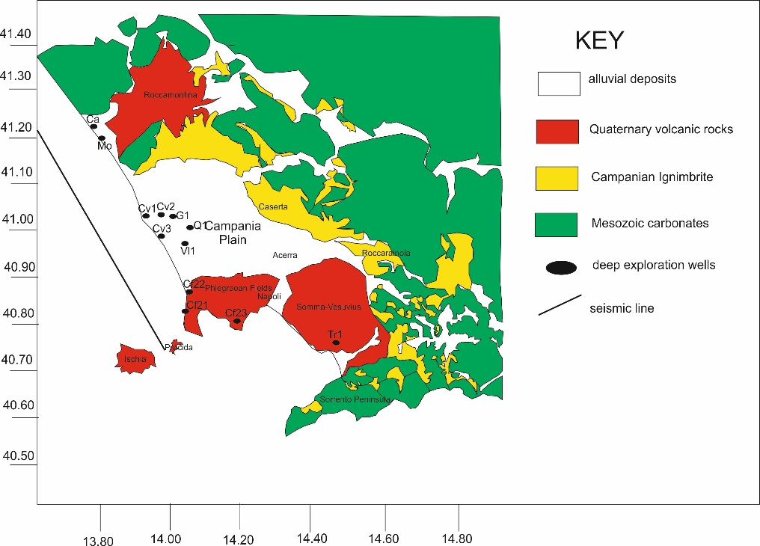
Figure 1. Geologic sketch map of Campania plain, reporting the location of seismic profiles and exploration wells.

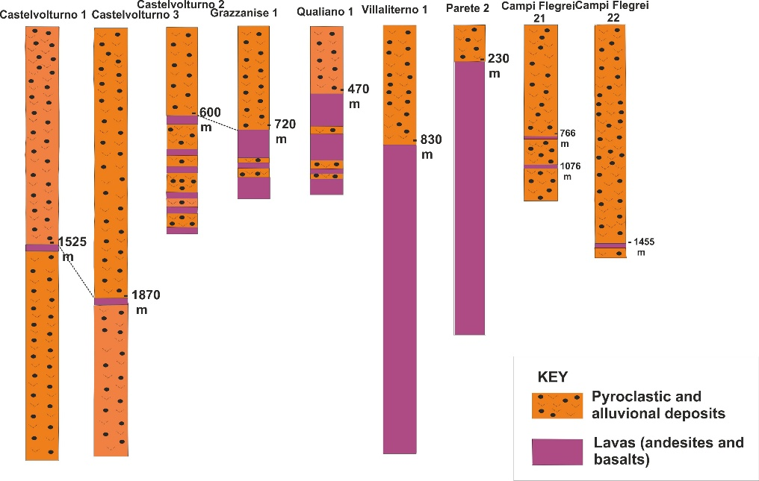
Figure 2. Sketch stratigraphy of deep exploration wells. Stratigraphic correlation of volcanic deposits has also been reported.
The stratigraphic architecture of the Volturno valley fill is characterized by six facies associations (Amorosi et al., 2012; 2013), Holocene in age, unconformably overlying the Late Pleistocene alluvial deposits, which, in turn, unconformably overlie an acoustic basement represented by the Campanian Ignimbrite volcanic deposits (Barberi et al., 1978; Fitsimmons et al., 2013). The swamp facies association is composed of clays with abundant volcanic materials. The lagoon-estuary facies association is composed of silty clays with sandy intercalations. The transgressive barrier facies association is distinguished by fine-grained sands grading upwards to silty sands and silts. The prodelta facies association, recognized in correspondence to the present-day Volturno river mouth and probably extending seawards in the inner continental shelf of the Volturno river (Cuma offshore; Iorio et al., 2014) is characterized by silty clays with local silt and sand intercalations (Amorosi et al., 2012; 2013). The beach ridge facies association is composed of siliceous sands with abundant shells of marine fragments and crops out onshore in sedimentary bodies elongated alongshore. The top of Holocene succession is characterized by modern alluvial plain deposits, consisting of clays and silty clays with abundant fragments of plants and pumices.
The stratigraphic setting of the Patria Lake deposits has been recently described based on the core sedimentological data (Sacchi et al., 2014). The Upper Quaternary succession of the Patria Lake area is characterized by four main stratigraphic units, which are, in turn, sandy and clayey silts of a transitional environment, sands and silty sands (foreshore-nearshore and coastal bar systems), ash lapilli and silty sands (post-Campanian Ignimbrite volcaniclastic deposits and related paleosols) and ash, lapilli, scoriae and pumiceous tuffs (Campanian Ignimbrite). The stratigraphy of the Holocene succession, characterized by marine to lagoonal depositional environments, is distinguished from sandy silts with homogeneous texture (modern-ca AD 1713, cal. through radiocarbon dating) and finally, scoriaceous ash, pumice and lapilli with lithics (4800-6000 B.P., cal. through radiocarbon dating; Sacchi et al., 2014). A main paleosol, ranging in age from 6000 to 8000 BP has been interpreted as a pedogenetic interval, which has evidenced a phase of quiescence during the activity of the Phlegrean Fields.
The Volturno prodelta deposits have been recently studied based on the seismic interpretation coupled with the petrophysical and sedimentological core analysis (Iorio et al., 2014). The tephrostratigraphic analysis has recently suggested that a continuous reflector identified in the Volturno shelf is represented by the Neapolitan Yellow Tuff (NYT) deposits (Aiello et al., 2017). The seismo-stratigraphic analysis of the Subbottom Chirp data has allowed for the identification of a Late Pleistocene prograding wedge, bounded at its top by the post-glacial Holocene ravinement surface, representing a main regional stratigraphic marker (Correggiari et al., 1992). This unconformity represents also the base of the Holocene transgressive deposits, while the Holocene highstand prodelta deposits overlie the maximum flooding surface (MFS; Mitchum et al., 1977; Vail et al., 1977).
A chronostratigraphic framework of the upper part of the Volturno prodelta deposits to about 2300 years BP has been provided by Iorio et al. (2014) based on the high resolution stratigraphic correlation of the colour chromaticity parameter. Ten lithological/petrophysical units have been recognized from the core sedimentological and petrophysical analyses and supported from the seismic interpretation. A slow sliding without reworking of the upper Holocene units has been evidenced from the seismic interpretation, suggesting the occurrence of a significant internal deformation of the seismic reflectors. A sequence stratigraphic setting of the seismic sequences representing the upper part of the Volturno prodelta deposits has also been provided accordingly to the recent literature (Zecchin and Catuneanu, 2013).

Materials and Methods

The seismic reflection techniques strongly changed during the last years. The contribution to this change mostly comes from the oil industry, employing many resources in the geophysical methods for the oil searching. The basic techniques for the seismic exploration consist of the generation of artificial seismic waves in the ground (source) and in the measurement of the time requested from these waves to cover the distance from the source to the receiver. The pathway of the seismic rays may be reconstructed from the knowledge of the times of arrival to several recorders and of the corresponding velocities. The reconstruction of the seismic ray pathway may happen through the refraction, if we consider the times of the refracted phases, or for the reflection, if we consider the reflected phases (Sheriff and Geldart, 1995). One of the main advantages of the seismic reflection method is the not-necessary condition of the increase of the velocity with the depth. An abrupt velocity variation, both in the increase and in the decrease, is enough to determinate a reflection of the elastic waves at the surface of discontinuity.
The sequence stratigraphic criteria and the stratigraphic concepts in the clastic continental shelves have been recently updated (Zecchin and Catuneanu, 2013). The system tracts, which are the basic stratigraphic units of the depositional sequences in the sequence stratigraphic models, are directly related with a particular type of shoreline trajectory and the related eustatic sea level fluctuations, including the transgression, the normal regression (lowstand or highstand) and the forced regression. The transgressive system tract (TST) is bounded at its base by a ravinement surface and at its top by a maximum flooding surface. The stratigraphic architecture is characterized by the retrogradational strata, resulting from the rates of the accommodation space outspacing those of the sediment supply at the shoreline, typically accompanied by a trend of deepening-upward in the shallow marine environments.
The normal regressive system tracts are represented by the lowstand and highstand system tracts. They may be located between the transgressive deposits, located below and the forced regression (above) strata (in particular the Highstand System Tract, HST) or between the forced regressive (below) and the transgressive (above) strata (the Lowstand System Tract, LST, in particular). Accordingly to the interpretation of Zecchin and Catuneanu (2013), the normal regressive system tracts may be bounded by several sequence stratigraphic surfaces, as a result of their position relatively to other system tracts within a depositional sequence.
The Falling Stage System Tract (FSST) consists of the forced regressive deposits and forms during a relative sea level fall, when the shoreline is forced to retreat irrespective to the sediment supply. The shelf portion of the FSST commonly displays a foreshortening of the prograding clinoforms, due to the progressive decrease in the accommodation space during the geological time, which results in thinner deposits proceeding seawards (Hunt and Tucker, 1992; Helland-Hansen and Gjelberg, 1994; Plint and Nummendal, 2000). The FST deposits are normally characterized by the offlap terminations, without the development of topsets due to the prevalent conditions of the negative accommodation (Hunt and Tucker, 1992; Helland-Hansen and Gjelberg, 1994).
The acquisition of a new multichannel seismic profile in the area of the Volturno Basin has allowed to construct an interpreted geological section, showing the stratigraphic relationships among the seismic units individuated through the criteria of the seismic stratigraphy (Mitchum et al., 1977; Vail et al., 1977). The seismic line herein presented allows to show the geological framework and the deep structure of the investigated area, particularly referring to the relationships between the acoustic basement and the sedimentary filling in the basin interior. The commercial seismic lines recorded by the Agip oil company (“Zone E”; Agip multichannel seismics) and the lithostratigraphic data of deep exploration wells located on the Campania-Latium Tyrrhenian margin have been used (Figure 2; Ippolito et al., 1973; Ortolani and Aprile, 1978) in order to integrate the seismic lines collected during the cruise Sister99 (Bertotti et al., 1999; Aiello et al., 2011a; 2011b).
The deep well lithostratigraphic data pertain to the different wells (Castelvolturno 1, Castelvolturno 2, Castelvolturno 3, Grazzanise 1, Qualiano 1, Villaliterno 1, Parete 2, Campi Flegrei 21; Campi Flegrei 22), whose sketch stratigraphy is reported in Figure 2. These wells have drilled the pyroclastic and alluvial deposits, overlying lavas represented by andesites and basalts, which are thickest in Villaliterno 1 and Parete 2 wells, drilling the Villa Literno volcanic complex (Ippolito et al., 1973; Ortolani and Aprile, 1978; Aiello et al., 2011a).

Regional Geologic Setting

The Tyrrhenian basin represents a back-arc extensional basin, whose development has been controlled by the subduction of the lithosphere of the African plate under the European plate during the Neogene and the Quaternary (Boccaletti and Guazzone, 1974; Malinverno and Ryan, 1986; Royden et al., 1987; Doglioni, 1990). Its extension started at about 10 My ago, leading to the formation of the continental lithosphere during the Pliocene (Patacca and Scandone, 1989; Sartori, 2003; Doglioni et al., 2004; Mattei et al., 2004; Lustrino and Wilson, 2007; Cloetingh et al., 2008; Aiello et al., 2014). The extensional processes in the Tyrrhenian basin have been accompanied by the development of the complex phases of the compression, the strike-slip fault development and the extension, coupled with the counter-clockwise rotation of the thrust sheets in the Southern Apennines (Channell et al., 1990; Oldow et al., 1993).
Three continental margins i.e., the Sardinia margin, the Northern Sicily margin and the Southern Italy margin bound the Southern Tyrrhenian bathyal plain. This area is characterized by an active seismicity and volcanism and has undergone the horizontal and vertical movements. A narrow and deep Benioff zone, extending from the Ionian sea to the Tyrrhenian sea has evidenced the occurrence of a migrating eastwards subduction plan of the lithosphere of the Eastern Mediterranean (Sartori, 2003). Starting from the Oligocene and since recent times the processes of subduction have generated the western Mediterranean and Tyrrhenian back-arc basins, as well as the accretionary wedge of the Southern Apennines.
The extension in the Tyrrhenian sea started from the Late Miocene and controlled the formation of the oceanic lithosphere in the Marsili and Vavilov basins during the Plio-Quaternary (Kastens et al., 1988; Savelli and Schreider, 1991; Trua et al., 2007; Savelli, 2015; Sallares et al., 2016). The latest realization of the arc volcanism with respect to the duration of the extensional processes in the Tyrrhenian-Ionian system has been explained as a consequence of the initial stages of the thinned continental lithosphere (Ritsema, 1979; Malinverno and Ryan, 1986; Sartori, 2003). The age and the trending of the extensional processes have been previously discussed (Sartori and Capozzi, 1998). An episode of back-arc extension, ranging in age from the Tortonian to the Pliocene in correspondence to the Sardinian margin and to the Vavilov basin, has indicated an arc migration from west to east. A Pleistocenic extensional episode, corresponding to the formation of the Marsili basin, has indicated an arc migration from north-west to south-east.
The tomographic models and the seismic reflection and refraction surveys have been carried out in order to study both the subduction and the back-arc extension in the Tyrrhenian sea (Faccenna et al., 1997; 2004; 2007; Sartori et al., 2004; Castellano et al., 2008; Guillaume et al., 2010; Malinverno, 2012; Moeller et al., 2013; Aiello et al., 2014; Greve et al., 2014; Prada et al., 2014; Ranero et al., 2015; Savelli, 2015; Sallares et al., 2016). The styles of the back-arc extension in the Central Mediterranean, including the Tyrrhenian sea, have been discussed in detail (Faccenna et al., 1997). In the Northern Tyrrhenian basin the extensional areas progressively migrate eastwards, whereas in the Southern Tyrrhenian basin the extensional areas and the volcanism migrated inside the basin, controlling a continental break-up and a drifting of the previously formed older conjugate basins.
The Campania continental margin, as well as the Sardinia continental margin, is bounded by the asymmetrical highs of the acoustic basement, where the pre-Miocene sedimentary rocks have been sampled (Dal Piaz et al., 1983; Gennesseaux et al., 1986). Some evidence including the comparable water depths, the occurrence of sedimentary basins underlying the Campania continental margin and the probable occurrence of Messinian evaporites as a marker horizon (Fabbri and Curzi, 1979) has suggested a similar geologic behavior of the Campania and Sardinia continental margins (Rehault et al., 1987; Sartori et al., 2004).
On the Campania-Latium Tyrrhenian margin the peri-tyrrhenian basins often form the seaward prolongation of the coastal plains produced by the Plio-Quaternary extensional tectonics (Mariani and Prato, 1988; Brancaccio et al., 1991; Cinque et al., 1997). The tectono-sedimentary evolution of these basins is connected with the Neogene tectonic evolution of the Apenninic chain (Royden et al., 1987; Patacca and Scandone, 1989). As suggested by previous studies, the tectonic setting of peri-tyrrhenian basins is characterized by alternating compressional and extensional phases during the Plio-Quaternary (Bartole, 1984; Argnani and Trincardi, 1990; Agate et al., 1993; Sacchi et al., 1994; Aiello et al., 2000; 2011a; 2011b; Pepe et al., 2000; Sartori et al., 2004; Conti et al., 2017).
The Gulf of Naples, together with the Campania Plain, represents one of the most important Neogene-Quaternary basins of the peri-tyrrhenian area. It is located in a sector linking the southern Apennines and the Tyrrhenian sea, whose tectonic setting is strictly related with the geodynamic evolution of the back-arc basin Apenninic chain-foredeep system during Late Neogene and Quaternary times. The extensional processes in the Tyrrhenian area were contemporaneously active together with the compressional tectonic phases, leading to the individuation of the Apenninic chain and to the migration of the foredeep chain system towards the Apulian foreland (Malinverno and Ryan, 1986; Oldow et al., 1993; Ferranti et al., 1996; Casciello et al., 2006; Patacca and Scandone, 2007). Previous studies have evidenced that the peri-tyrrhenian area, in particular along the Campania continental margin, is characterized by the occurrence of sedimentary basins, perpendicular to the chain, individuated in correspondence to the normal faults, having a north-east to south-west trending (Bartole et al., 1983; Mariani and Prato, 1988; Sacchi et al., 1994; Acocella et al., 1999; Aiello et al., 2000; Milia and Torrente, 2003; Moeller et al., 2013).
The tectonic lineaments occurring at a regional scale in the Campania-Latium Tyrrhenian margin between the Gaeta Gulf and the Ischia island are represented by the Circeo structural high, a north-west to south-east trending structural high expressive of the seaward extension of the Circeo Promontory; the Terracina Basin, indicating a north-south trending half-graben, widening proceeding seawards and laterally joining into the Gaeta Basin; the Terracina-Gaeta structural high, which is a wide belt of structural highs located offshore the Gaeta town, signifying the physiographic separation between the Terracina and Gaeta basins; the Massico structural high, a a north-west to south-east trending structural high, representing the seaward prolongation of the Massico Mount; the Volturno Basin, characterized by a depocenter located in correspondence to the Volturno river mouth, where the thickness of the basin filling reaches 2.5 sec (based on seismic interpretation) at average corresponding to more than 2000 m (Aiello et al., 2000; Figure 3).
The distribution of the outcrops and the geological evolution of the depositional environments of the Late Miocene marine deposits, cropping out onshore in the Campania plain (Ortolani and Aprile, 1978), has indicated that, during the Late Miocene, the wide areas of the Tyrrhenian basin were characterized by a complex coastal morphology, distinguished from the shallow water environments. The large areas of the continental shelf then were individuated along the southern Tyrrhenian margin, where the deltaic systems were fed by the first Apenninic rivers (the proto-Tiber, for instance), bounded at their base by a tectonically-controlled unconformity, which fossilizes the syn-rift seismic sequences (Aiello et al., 2000; Figure 3).
A seismic study of the 41st parallel fault system offshore the Campanian-Latial continental margin has been carried out (Bruno et al., 2000). A set of seismic reflection lines, collected in the Southern Tyrrhenian sea offshore, has been interpreted. The obtained results have shown that the Campanian-Latial continental margin is characterized by the structural highs and the lows, matching the main structures of the mainland (Massico Mt, Volturno and Garigliano depressions).

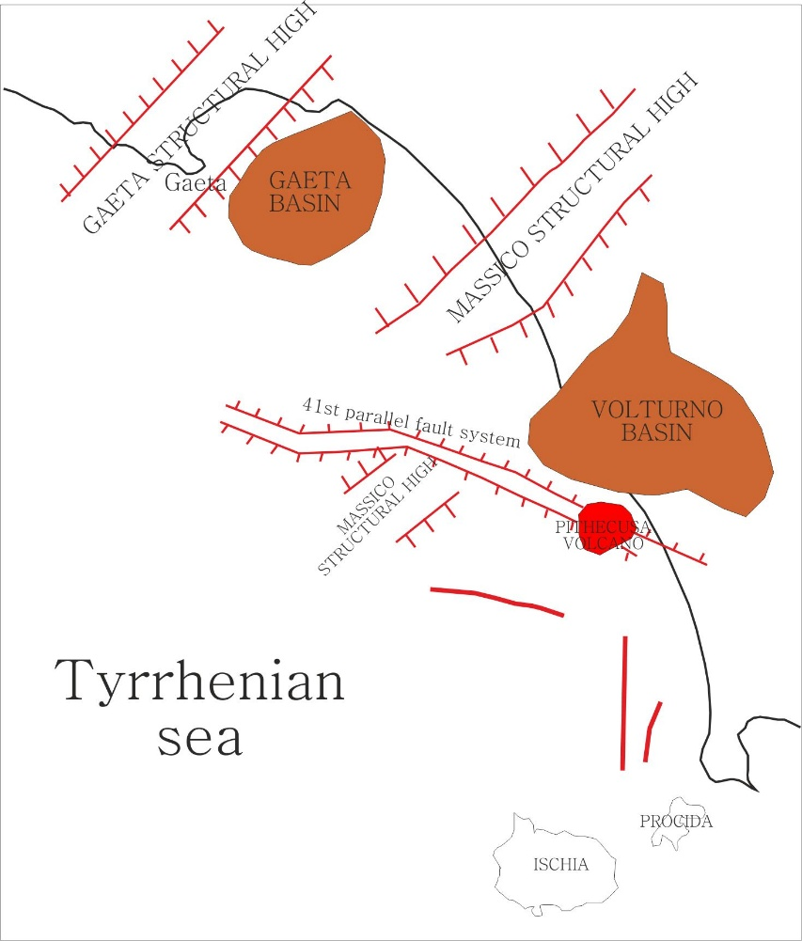
Figure 3. Sketch morpho-structural lineaments of the Campania-Latium continental margin.
The study area is characterized by ESE-WNW, E-W and NE-SW normal faults. The activity of these faults mainly developed during the Late Pliocene and the Early Pleistocene. The ESE-WNW to E-W faults have displayed the tectonic structures consistent with the strike-slip movements. These faults are located on the maximum gradient of the E-W elongated magnetic alignment of the 41st parallel fault zone. The relationships among the 41st parallel fault system and the Ortona-Roccamonfina (ORL) line have been studied. The seismic data have indicated that the ORL is older than the 41st parallel line. The normal movements along the ORL faults are consistent with a NW-SE extension, which is responsible for the longitudinal extension in the Southern Apenninic belt.
The interpretation of seismic profiles has allowed for the identification of the three seismo-stratigraphic units bounded by the two seismic horizons, representing the regional unconformities (Bruno et al., 2000). The seismic unit 1 consists of a sequence having a variable energy, characterized by the continuous and parallel reflectors. This unit has been differentiated in a lower depositional sequence, characterized by the prograding sedimentary patterns and in an upper sequence with the parallel to sub-parallel strata. The seismic unit 1 consists of a sequence having a variable energy, characterized by the continuous and the parallel reflectors. This unit has been differentiated in a lower depositional sequence, characterized by the prograding sedimentary patterns and in an upper sequence with the parallel to sub-parallel strata. The unit has been interpreted as the sedimentary and pyroclastic sequences, Plio-Quaternary in age and has been drilled by several exploration wells (Ortolani and Aprile, 1978). Accordingly to the well lithostratigraphic data of Ippolito et al. (1973), this sedimentary sequence is thick about 700 m in the plain located to the north of the Massico Mount, whereas its thickness exceeds 3000 m in the Campania Plain (Bruno et al., 2000). The seismic horizon A has been defined as the top of the seismic unit 2. It is represented by an erosional unconformity, corresponding to the Lower Pliocene unconformity and produced during a compressional tectonic phase (Hyppolite et al., 1994; Billi et al., 1997; Aiello et al., 2011a; 2011b).
The seismic unit 2 consists of two sub-units, respectively a seismic sequence of the continuous and parallel reflectors representing the Miocene-Pliocene sediments and the terrigenous succession, mainly Tertiary in age (“Sicilide and Liguride Complex”; Bonardi et al., 1992; Bigi et al., 1992).
The first sub-unit has been drilled by the lithostratigraphic wells located northwards of Massico Mt, while the second one has been drilled by the Cellole Aurunci 1 well (Ippolito et al., 1973). The seismic horizon B has been defined as the top of the seismic unit 3, appearing as a few cycles having a low frequency and a variable energy (Bruno et al., 2000).
The seismic unit 3 represents the top of the carbonate units, ranging in age from the Upper Triassic to the Early Miocene. The Triassic to Lower Miocenic limestones and dolomites of a carbonate platform environment crop out at the Massico Mount. The interpretation of the seismic data has allowed to reconstruct the depth of the Lower Pliocene unconformity, corresponding to the seismic horizon and to trace the main faults. The geological and geophysical constraints have also been taken into account (Mariani and Prato, 1988).
The significant changes in the rifting directions of the Campania-Latium continental margin have been recently evidenced, suggesting some new insights and constraints on the Tyrrhenian sea opening (Milia et al., 2013). The role of the deep normal faults of the Campania margin, specifically located in the Gaeta basin, has been constrained based on the seismic interpretation coupled with the structural geology. Three different basins have been depicted in the Gulf of Gaeta; in the northern and central basins a syn-rift sequence occurs, buried by the oldest aggradational deposits. A thick succession, older than 0.7 My filled the northern basin with a lateral aggradational geometry. A syn-tectonic wedge was deposited in the central basin, ranging in age from 0.7 My and 0.4 My. A thick deposit, younger than 0.4 My has suggested the collapse of the southern basin. The interpretation of the Crop section, extending from the Vavilov bathyal plain of the Tyrrhenian sea to the Gaeta Gulf has evidenced a multi-phase rifting, where the rifting processes migrated during the geological time and the mode of rifting changed through the geological time (Milia et al., 2013).
A study of the geological evolution in the Gaeta Bay sedimentary infill has been recently carried out (Iannace et al., 2013). This study, based on the multichannel seismic reflection profiles has been focused on the seismic stratigraphy of the sedimentary succession of this region of the Eastern Tyrrhenian margin. A digital model of the Gaeta Bay infill has been constructed using the Kingdom software, permitting to reconstruct the three-dimensional stratigraphic architecture of the depositional sequences of the Gaeta Bay. Two sub-basins, i.e., the northern one and the central one, have been modelled, bounded by the normal faults and characterized by the high rates of subsidence. The complete stratigraphic succession has been recognized in the northern sector of the Gaeta Bay. The sedimentary infill of the basins overlies the Meso-Cenozoic acoustic substratum. It is formed by two unconformity-bounded units overlain by thirteen sequences, which are grouped into three sequence sets (A-C).
The basal unconformity-bounded units are wedge-shaped and were deposited during the fault activity and the basin formation. The sequence set A is characterized by the parallel reflectors, whose seismic facies suggest a regressive trend. The sequence set B is characterized by the prograding depositional units, with an aggradation of the toplap surface suggesting a new period of the rift basin subsidence. The sequence set C is instead characterized by the oblique prograding depositional units, indicating a post-rift infill of the northern part of the Gaeta Bay. The analysis of the resulting 2D and 3D distribution of the depositional units has allowed to reveal the architectural interpretation of the stratigraphic basin infill. The four-dimensional Quaternary paleogeographic evolution of the Gaeta Bay has been finally reconstructed (Iannace et al., 2013). The oldest unconformity-bounded unit (PP) has revealed at least two periods of the syn-rift fault activity, resulting in the dramatic palaeo-environmental changes. During the Late Pliocene-Early Pleistocene, the block-faulting affected the continental area, representing an emerged chain during that geological time. This block-faulting was responsible for the creation of the shallow-water basins, which were completely filled by sediments. A second step of the syn-rift activity was documented by the deposition of the unit Ux1. During this period a deepening of the basin occurred, due to the abrupt changes of the seismic facies and the distribution of the units Ux2 and Ux1. The digital map and isochrone model of the sequence set A have suggested an infill of this deep basin. The lower boundary of the sequence set B has marked an abrupt landward migration of the sedimentation (Iannace et al., 2013). The source area of sediments of the sequence set A has suggested an infill of this deep basin. This source area was probably represented by the Pontina and Garigliano plains (see also Aiello et al., 2000). The lower boundary of the sequence set B has marked an abrupt landward migration of the sedimentation, which came out together with the aggradational stacking pattern of the topset. This evidence has suggested a new event of the regional subsidence. During this stage, the listric normal faults affected the central basin of the Gulf of Gaeta and a syn-tectonic wedge deposited (Aiello et al., 2000; Aiello et al., 2011; Iannace et al., 2013; Milia et al., 2013). The sequence C has completely filled the basin. The reconstruction of the offlap breaks has recorded a rapid southwards migration of the continental shelf, indicating a regressive trend of the marine and coastal facies (Aiello et al., 2000). The toplap surface of this prograding succession forms the present wide continental shelf of the Gaeta Bay.

Data Acquisition and Processing

The data processing has represented an important part of the present paper and has been carried out through the use of a specific software dedicated to data processing. The techniques of data processing used for the elaboration of seismic profiles are up-to-date. Some of them are based on complex mathematic models, which have allowed to carry out a good attenuation of the multiples (especially the multiples occurring at the sea bottom) and to obtain good velocity analyses for the production of the stacked sections, on which the geological interpretation has been carried out.
Table 1. Acquisition parameters of multichannel seismic survey

Type of source | n. 2 guns GI Gun SI/Sodera (210 c.i.)
Length of the seismogram | 5 sec
Sampling interval | 1 msec
Distance among the sources | 25 m
Distance among the hydrophones | 12.5 m

The instruments and the employed advanced techniques have facilitated the production of high-quality seismic data, also in the areas where the wide occurrence of the pyroclastic levels and of the volcanic bodies controls a scattering of the energy of the elastic waves. In particular, the Airguns, a streamer having 48 channels and a system of data acquisition have been employed for the acquisition of the seismic line used to construct the regional geological section of the Volturno basin. The acquisition parameters are briefly resumed in Table 1.
The procedures of the processing of the multichannel seismic data starting from the field data are herein described. The used software are the Promax 2D (Landmark Ltd.) and the Seismic Unix (Colorado School of Mines).
The elaboration of the seismic data has involved some similar processes (Yilmaz, 1988). Perhaps, a single flux of data elaboration, comprehensive for all the seismic lines, has been constructed. Some advanced processes have been applied to a basic flux of elaboration in order to fully enhance the useful signal occurring in the seismic data. The post-stack elaboration has involved the filter on the auto-vectors, which has not produced a further improvement of the stacked sections. As a consequence, this filter has not been applied. The data have been prepared in such a way to produce stacked sections, ready to be migrated and interpreted.
The initial procedure of the seismic processing consisted of the quality control of the seismic data and of the assignment of the field geometry. The editing of the seismic traces has been finalized to the survey of the seismic traces and of the spikes, which could induce problems with the Fast Fourier Transform (FFT). A top muting has eliminated the seismic signal above the first arrivals of the seismic traces. The Automatic Gain Control (AGC) has allowed for a normalization of the seismic traces. The data processing has been finalized to reduce the casual noise occurring in the seismic data and to improve the resolution of the seismic wavelet through the algorithms of the deconvolution and of the spiking.
The velocity analysis has been carried out in order to remove the move-out on the families of CDP aimed at defining the velocity of the different seismic reflectors and at producing the final stacked section. A post-stack deconvolution has been applied to the data in order to remove the arrivals of the multiples. A bandpass filter has been applied after the deconvolution in order to improve the signal involved along the seismic sections. The seismic interpretation has been carried out according to the criteria of seismic stratigraphy and taking into account the multiples and the seismic noise.

Results

Seismic Interpretation

The seismic interpretation has been carried out according to the criteria of seismic stratigraphy, allowing for the recognition of different seismic units. In this interpretation, the lithology of the seismic units has been inferred from the lithostratigraphic well data (Agip, 1977; Figure 2) and from the onshore seismic data collected in the Volturno Basin (Mariani and Prato, 1988; Aiello et al., 2011a).
The seismic units are described proceeding from the deepest ones to the youngest ones (Figures 4 and 5). The deepest unit is characterized by discontinuous reflectors of high to medium amplitude. The top of the seismic unit is located at depths ranging between 1650 m and 2025 m. The unit appears to be down thrown by several normal faults, whose throws are in the order of several tens of meters (Figure 5). The unit has been
interpreted as the Meso-Cenozoic carbonates (MC in Figure 5) pertaining to the Campania-Lucania carbonate platform, widely cropping out in the onshore sectors (D’Argenio et al., 1973; Mariani and Prato, 1988; Bigi et al., 1992) and already documented in the Volturno offshore based on the deep multichannel seismic data (Aiello et al., 2000; Bruno et al., 2000).

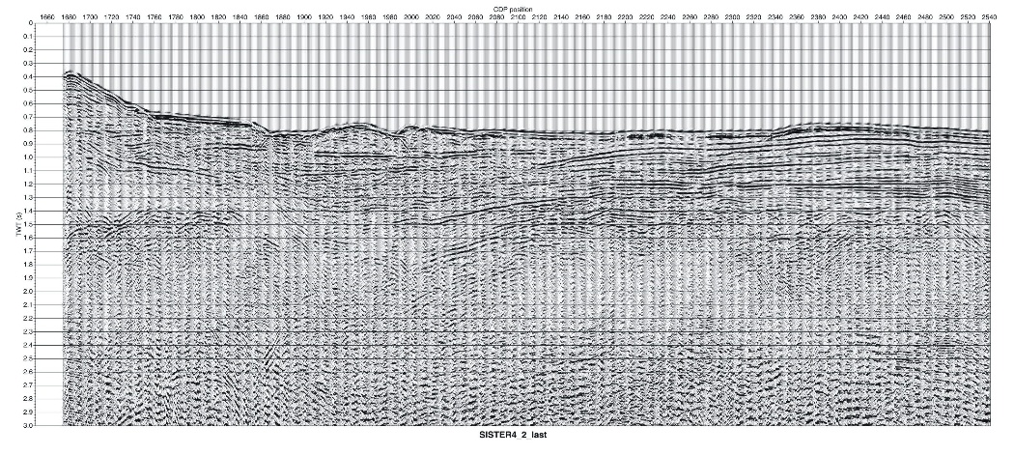
Figure 4. Seismic section Sister4_2 after stacking.

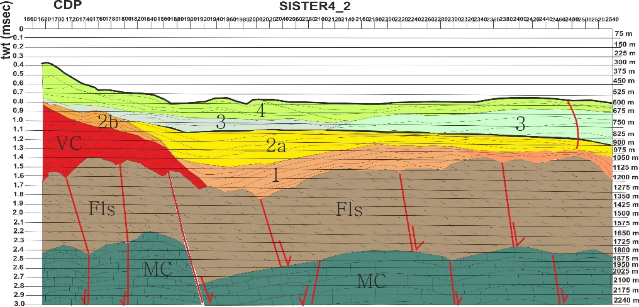
Figure 5. Interpreted seismic section of the Volturno Basin.

The overlying seismic unit is characterized by an acoustically-transparent seismic facies with rare and scattered discontinuous seismic reflectors. The top of the seismic unit is located at depths ranging between 1050 m and 1350 m. The average thickness of the unit is in the order of 750 meters. The top of the unit, corresponding with a highly continuous seismic reflector, is strongly down thrown in correspondence with the normal faults, whose throws are in the order of several tens of meters. This unit has been interpreted as genetically related with the “Flysch di Frosinone” Auct., (FLS in Figure 5), pertaining to the Miocene flysch of Central Apennines, whose occurrence has been well constrained from different outcrop studies (Accordi, 1964; Bigi et al., 1992; Parotto and Praturlon, 1975; Accordi et al., 1986; Civitelli and Corda, 1988; Cipollari and Cosentino, 1992) and from previous seismic studies on the Volturno offshore (Aiello et al., 2000; Bruno et al., 2000).
The FLS unit is overlain by two different seismic units, respectively volcanic and sedimentary in origin and characterized by the facies hetheropy. The first one (VC in Figure 5) is distinguished from an acoustically-transparent seismic facies and from a wedge-shaped external geometry (Figure 4). This unit has been interpreted as the volcanic deposits pertaining to the Villa Literno volcanic complex (Ippolito et al., 1973; Ortolani and Aprile, 1978; Aiello et al., 2011). In the Campania plain among the oldest volcanic products there are the basalts and the andesites and basaltic lavas dated back to about 2 My B. P., encountered in the subsurface in the Parete-Villa Literno area during the drilling finalized to the geothermal research (Di Girolamo et al., 1978; Ortolani and Aprile, 1978). The unit has an average thickness of 600 m. The second one represents the oldest unit of the sedimentary basin filling (1 in Figure 5) The top of the seismic unit 1 ranges in depth from 1125 m to 1050 m. The two units are overlain by two different seismic units (2a and 2b in Figure 5). The seismic unit 2a has been interpreted as a relict prograding wedge, downlapping on the volcanic rocks of the Villa Literno volcanic complex. On the other side, the seismic unit 5b is characterized by discontinuous and parallel to sub-parallel seismic reflectors. It has been interpreted as alternating sands and shales of a deltaic environment, Pleistocene in age (Figure 3; Mariani and Prato, 1988). The overlying seismic unit 3 (Figs. 4 and 5) is characterized by the parallel to sub-parallel seismic reflectors having a high amplitude. It has been interpreted as alternating sands and shales of a deltaic environment, Pleistocene in age (Figure 3; Mariani and Prato, 1988). Finally, the seismic unit 4 (Figs. 4 and 5) is distinguished from the parallel to sub-parallel seismic reflectors, from discontinuous to continuous. It has been interpreted as shales of coastal environment (Pleistocene).

Stratigraphic Correlation of Deep Lithostratigraphic Data

A qualitative stratigraphic correlation between the deep lithostratigraphic data collected in the Volturno Plain up to the Phlegrean offshore, whose stratigraphy is shown in Figure 3, has been constructed and hereafter shown (Figure 3) with the aim to highlight both the trend and the depth of the pyroclastic and alluvial deposits, relatively to the lavas (andesites and basalts) pertaining to the Villa Literno volcanic complex. The two main groups of the crossed grounds are respectively represented by the pyroclastic and alluvional deposits, representing the filling of the Volturno Plain and by the lavas (andesites and basalts), pertaining to the Villa Literno volcanic complex.
The thickness of the lava deposits is minimum at the Castelvolturno 1 and Castelvolturno 3 wells, whose top is respectively located at depths of 1525 m and 1870 m (Figure 3).
A stratigraphic correlation has been constructed also for the wells Castelvolturno 2, Grazzanise 1, Qualiano 1, Villa Literno 1 and Parete 2 due to comparable depths (Figure 3). The top of the volcanic deposits has been found at 600 m (Castelvolturno 2), 720 m (Grazzanise 1), 470 m (Qualiano 1), 830 m (Villa Literno 1) and 230 m (Parete 2). The thickness of the volcanic deposits increases from the Castelvolturno town to the Villa Literno and Parete towns.
It is noteworthy for the calibration of the interpreted seismic section to mention the data of the Cellole Aurunci 1 and Mondragone 1 wells. The Cellole Aurunci 1 well has drilled, below a layer of 75 m of recent alluvial deposits, alternating shales, sandstones and conglomerates, ranging in age from the Quaternary to the Pliocene and the Miocene. Up to a depth of 675 m, the Mondragone 1 well has crossed the grounds pertaining to the Quaternary, mainly composed of sands with volcanic elements and of conglomerates with intercalations of marls. Below 675 m this well has drilled the Miocene deposits, characterized by alternating conglomerates, sands, sandstones and marly sandstones.
The Castelvolturno 1 and the Castelvolturno 3 wells have shown the clastic deposits, varying from the marine to the continental environments up to 3000 m of depth. In the inner part of these deposits two intercalations of volcanic deposits have been found between 1430 and 1450 m (Castelvolturno 1) and between 1800 and 1830 m (Castelvolturno 3).
In the lithostratigraphic wells Castelvolturno 2, Grazzanise 1 and Qualiano 1, the thickness of lavas interstratified with levels of sands and shales increases and it is possible to find them at higher depths, respectively of 475, 720 and 500 m.
In the well Villa Literno 1, below the recent pyroclastic deposits 150 m of andesitic tuffs have been found, 650 m of clastic deposits of a marine and transitional environment and finally, from 830 m to 2980 m, alternating effusive rocks of a basaltic and andesitic type and tuffs. In the last ten meters alternating sands and shales, Tertiary in age, have been found.
In the well Parete 2, below the recent pyroclastic products alternating with clastic deposits (first 300 m), alternating basaltic and andesitic lavas have been found up to the bottom of the well (1800 m).

Calibrated Geological Section

The first group of grounds may be used in the calibration of the interpreted seismic section. In fact, the pyroclastic and the alluvial deposits well correlate with the seismic units 2a, 3 and 4 (Figures 4 and 5), representing the basin filling of the offshore sector of the Volturno plain. Otherwise, the second group of grounds, represented by the lavas (andesites and basalts) pertaining to the Villa Literno volcanic complex well correlates with the seismic unit 2a (Figures 4 and 5).
Taking into account the lithostratigraphic data of the Cellole Aurunci 1 and Mondragone 1 wells, the FLS unit, representing Miocene flysch deposits, should be composed of alternating shales, sandstones, conglomerates and marly limestones. These deposits should be genetically related with the “Flysch di Frosinone” Auct. (Bigi et al., 1992).
The seismic and well data have shown that the carbonate basement, identified in the interpreted seismic section, deepens in the western side of the Campania Plain up to depths highest than 3 kilometers. The age of the deposits ranges from the Miocene and the Quaternary (Cellole Aurunci and Mondragone 1 wells), while in the Castelvolturno 1 well only Quaternary deposits have been identified, up to a depth of 3 km. It can perhaps be hypothesized that the Miocene sequence, drilled in the wells Cellole Aurunci 1 and Mondragone 1, may occur also below the Castelvolturno well (Ippolito et al., 1973; Billi et al., 1997; Aiello et al., 2011a).
In the Northern Phlegrean Fields well data have not shown the carbonate basement, encountered in the Somma-Vesuvius area at the Trecase 1 exploration well (Principe et al., 1987).

Conclusion

The seismo-stratigraphic data herein shown for the Volturno Basin have confirmed that it represents a half-graben characterized by the blocks down thrown along the normal faults, mainly affecting the top of the Miocene siliciclastic sequences (Figures 4 and 5). The seismo-stratigraphic evidence has highlighted that the period of activity of these normal faults lasted from the end of the Late Miocene (the assumed age of the Frosinone Flysch; Parotto and Praturlon, 1975) to the Early Pleistocene (the assumed age of the first seismic sequence of the basin filling; Mariani and Prato, 1988). Moreover, the basal sequence (1 in Figure 5) has evidenced the wedging geometries, indicating that it was deposited during the tectonic activity of the Volturno basin, perhaps synsedimentary in nature (Figure 5).
As it is a distinctive characters of other sedimentary basins offshore Campania, the volcanic deposits are well-developed and are interlayered in the sedimentary basin filling. This is also the case of the volcanic body which is genetically related with the Villa Literno volcanic complex, recognized in the discussed seismic section (Figs. 4 and 5) and correlating with the Quaternary volcanites drilled by the Villa Literno 1 well
(Figure 3).
The emplacement of this volcanic body appears to be younger than the most of the tectonic extension in the Volturno Basin. It cannot be excluded that the normal faults represented preferential pathways for magma uprising of the VC volcanic complex.
Some concluding remarks are herein exposed. The four main seismic sequences corresponding with the seismic units recognized onshore (Mariani and Prato, 1988) have been drafted in the Volturno Basin based on the seismo-stratigraphic analysis of the deep multichannel seismic profiles (Figures 4 and 5). Their lithology has been calibrated through the deep exploration well data (Figure 3).
The first seismic sequence (1 in Figure 5) is characterized by discontinuous to continuous seismic reflectors, from parallel to sub-parallel. It is composed of sands, conglomerates and shales with levels of pyroclastites, Early Pleistocene in age. The sequence onlaps on the side of the VC volcanic seismic unit (Figure 5), representing the volcanites genetically related to the Villa Literno volcanic complex. The wedging geometries have been observed, suggesting its synsedimentary nature.
It may be suggested that the intrusion of the VC volcanic unit is older than the deposition of the seismic unit 1, as highlighted by the onlap of the aforementioned sequence on the sides of the volcanic rocks.
The second seismic sequence (2 in Figure 5) has been divided into two main sub-sequences, respectively identified on the continental shelf (2a in Figure 5) and in the basin (2b in Figure 5). The sub-sequence 2a is distinguished from prograding clinoforms and represents a relict prograding wedge downlapping the VC volcanic complex. The sub-sequence 2b shows parallel to sub-parallel seismic reflectors and is composed of alternating sands and shales of deltaic environment, Pleistocene in age.
The third seismic sequence (3 in Figure 5) is distinguished from parallel to sub-parallel seismic reflectors having a high amplitude. It is formed by alternating sands and shales of deltaic environment.
The fourth seismic sequence shows discontinuous to continuous and parallel to sub-parallel seismic reflectors. It is composed of clays of a coastal environment, Pleistocene in age.
Our data are in agreement with previous seismic data on the Campania-Latium Tyrrhenian margin, both at a crustal scale (Milia et al., 2003; Sartori et al., 2004; Aiello et al., 2011a; 2011b) and at an intermediate scale (Aiello et al., 2009; Conti et al., 2017). The structure of the Campania-Latium continental margin appears to be controlled by the asymmetric fault systems, characterized by a main detachment level, by different listric normal faults and by roll-over anticlines. The transfer zones have also been suggested (Conti et al., 2017).

References

Accordi, B (1964). Lineamenti strutturali del Lazio e dell’Abruzzo meridionale. Memorie della Società Geologica Italiana, 4, 595-633.
Accordi, G., Carbone, F., Civitelli, G., Corda, L., De Rita, D., Esu, D., Funiciello, R., Kotsakis, T., Mariotti, G., Sposato, A. (1986) Lithofacies map of Latium-Abruzzi and neighbouring areas, scale 1 :250.000. Progetto Finalizzato Geodinamica, CNR.
Acocella, V., Salvini, F., Funiciello, R., Faccenna, C. (1999) The role of transfer structures on volcanic acivity at Campi Flegrei (southern Italy). Journal of Volcanology and Geothermal Research, 91, 123-139.
Agate, M., Catalano, R., Infuso, S., Lucido, M., Mirabile, L., Sulli, A., (1993). Structural evolution of the Northern Sicily continental margin during the Plio-Pleistocene. In: Max M. D. and Colantoni P. (Eds.) Geological Development of the Sicilian-Tunisian Platform. Unesco Reports in Marine Sciences. 58, 19-24.
Agip, (1977). Deep lithostratigraphic data of exploration wells. S. Donato Milanese, Italy.
Aguzzi, M., Amorosi, A., Sarti, G., (2005). Stratigraphic architecture of Late Quaternary deposits in the Lower Arno Plain (Tuscany, Italy). Geologica Romana, 38, 1-10.
Aiello, G., Marsella, E., Sacchi, M., (2000). Quaternary structural evolution of Terracina and Gaeta basins (Eastern Tyrrhenian margin, Italy). Rendiconti Lincei. 11, 41-58.
Aiello, G., Cicchella, A. G., Di Fiore, V., Marsella, E. (2011a). New seismo-stratigraphic data of the Volturno Basin (northern Campania, Tyrrhenian margin, southern Italy): implications for tectono-stratigraphy of the Campania and Latium sedimentary basins. Annals of Geophysics, 54 (3), 265-283.
Aiello, G., Marsella, E., Cicchella, A. G., Di Fiore, V. (2011b). New insights on morpho-structures and seismic stratigraphy along the Campania continental margin (Southern Italy) based on deep multichannel seismic profiles. Rendiconti Lincei, 22, 349-373.
Aiello, G., Di Fiore, V., Marsella, E., Passaro, S., (2014). High resolution seismic data coupled to Multibeam bathymetry of Stromboli island collected in the frame of the Stromboli geophysical experiment : implications with the marine geophysics and volcanology of the Aeolian Arc volcanic complex (Sicily, Southern Tyrrhenian sea, Italy). Springerplus, 3/232, doi: 10.1186/2193-1801-3-232.
Aiello, G., Insinga, D. D., Iorio, M., Meo, A., Senatore, M. R. (2017). On the occurrence of the Neapolitan Yellow Tuff tephra in the Northern Phlegrean Fields offshore. Italian Journal of Geosciences, 135 (2), doi: 10.3301/IJG.2017.06.
Amorosi, A., Milli, S. (2001). Late Quaternary depositional architecture of Po and Tevere river deltas (Italy) and worldwide comparison with coeval deltaic successions. Sedimentary Geology, 144, 357-375.
Amorosi, A., Ricci Lucchi, M., Rossi, V., Sarti G., (2009). Climate change signature of small scale parasequences from late Glacial-Holocene transgressive deposits of the Arno valley fill. Palaeocl., Palaeoecol., 273, 142-152.
Amorosi, A., Pacifico, A., Rossi, V., Ruberti, D. (2012). Late Quaternary incision and deposition in an active volcanic setting : the Volturno valley fill. Sedimentary Geology, 282, 307-320.
Amorosi, A., Rossi, V., Sarti G., Mattei, R. (2013). Coalescent valley fills for the late Quaternary record of Tuscany (Italy). Quaternary International, 288, 129-138.
Argnani, A., Trincardi, F. (1990). Paola slope basin: evidence of regional contraction on the Eastern Tyrrhenian margin. Memorie della Società Geologica Italiana, 44, 93-105.
Barberi, F., Innocenti, F., Lirer, L., Munno, R., Pescatore, T., Santacroce, R. (1978). The Campanian Ignimbrite: a major prehistoric eruption in the Neapolitan area (Italy). Bulletin of Volcanology, 41-1, 10-31.
Bartole, R. (1984). Tectonic structure of the Latian-Campanian shelf (Tyrrhenian sea). Bollettino di Oceanologia Teorica ed Applicata, 3, 197-230.
Bellotti, P., Chiocci, F., L., Milli, S., Tortora, P., Valeri, P. (1994). Sequence stratigraphy and depositional setting of the Tiber delta: integration of high-resolution seismics, well logs and archaeological data. Journal of Sedimentary Research, B64, 416-432.
Bellotti, P., Milli, S., Tortora, P., Valeri, P. (1995). Physical stratigraphy and sedimentology of the Late Pleistocene-Holocene Tiber delta depositional sequence. Sedimentology, 42, 617-634.
Bellotti, P., Calderoni, G., Di Rita, F., D’Orefice, M., D’Amico, C., Esu, D., Magri, D., Preite-Martinez, M., Tortora, P., Valeri, P. (2011). The Tiber river delta plain (central Italy): coastal evolution and implications for the ancient Ostia Roman settlement. The Holocene, 21, 1105-1116.
Bellotti, P., Caputo, C., Valeri, P. (2012). Delta types along the coast of the Italian Peninsula. Considerations on evolutive factors. Atti del Quarto Simposio Internazionale Il Monitoraggio Costiero Mediterraneo: problematiche e tecniche di misura. CNR Istituto di Biometereologia Editore, 205-212.
Bertotti, G., Marsella, E., Pelosi, N., Pepe, F., Tonielli, R. (1999). Sister 99: a seismic campaign to investigate the kinematics of South Tyrrhenian extensional regions. Giornale di Geologia, 61, 25-36.
Bicket, A. R., Rendell, H. M., Claridge, A., Rose, P., Andrews, J., Brown, F. S. J. (2009). A multiscale geoarcheological approach from the Laurentine shore (Castelporziano, Lazio, Italy). In Ghilardi M. et al., (Eds.) Geoarcheology: human environment connectivity. Geomorphology: relief, processus, environment, 4, 257-270.
Bigi, G., Bonardi, G., Catalano, R., Cosentino, D., Lentini, F., Parotto, M., Sartori, R., Scandone, P., Turco, E. (1992). Structural model of Italy 1:500.000. CNR Progetto Finalizzato Geodinamica, Roma, Italy.
Billi, A., Bosi, V., De Meo, A. (1997). Structural characterization of Mount Massico in the framework of the Quaternary evolution of the coastal depressions of the Garigliano and Volturno rivers (northern Campania, Italy). Italian Journal of Quaternary Sciences, 10 (1), 15-26.
Boccaletti, M., Guazzone, G. (1974). Remnant arcs and marginal basins in the Cenozoic development of the Mediterranean. Nature, 252, 18-21.
Bonardi, G., Amore, F. O., Ciampo, G., De Capoa, P., Miconnet, P., Perrone, V. (1992). Il Complesso Liguride Auct: stato delle conoscenze e problemi aperti sulla sua evoluzione pre-appenninica ed i suoi rapporti con l’arco calabro. Memorie della Società Geologica Italiana, 41, 17-35.
Brancaccio, L., Cinque, A, Romano, P., Rosskopf, C., Russo, F., Santangelo, N., Santo, A. (1991). Geomorphology and neotectonic evolution of a sector of the Tyrrhenian flank of Southern Apennines (Region of Naples, Italy). Zeitsch fur Geomorphologie, 82, 47-58.
Bruno, P. P. G., Di Fiore, V., Ventura, G., (2000). Seismic study of the 41st parallel fault system offshore the Campanian-Latial continental margin, Italy. Tectonophysics, 324 (1-2), 37-55.
Casciello, E., Cesarano, M., Pappone, G., (2006). Extensional detachment faulting on the Tyrrhenian margin of the southern Apennines contractional belt. Journal of the Geological Society of London, 163, 617-629.
Castellano, M., Augusti, V., De Cesare, W., Favali, P., Frugoni, F., Montuori, C., Sgroi, T., De Gori, P., Govoni, A., Moretti, M., Patanè, D., Cocina, O., Zuccarello, L., Marsella, E., Aiello, G., Di Fiore, V., Ligi, M., Bortoluzzi, G., Ferrante, V., Marchetti, E., La Canna, G., Ulivieri G. (2008) Seismic tomography experiment at Italy’s Stromboli volcano. Eos, 89 (30), 269-276.
Channell, J. E. T., Oldow, J. S., Catalano, R., D’Argenio, B. (1990). Paleomagnetically-determined rotations in the western Sicilian fold and thrust belt. Tectonics, 9, 641-660.
Cinque, A., Aucelli, P. P. C, Brancaccio, L., Mele, R., Milia, A., Robustelli, G., Romano, P., Russo, F., Santangelo, N., Sgambati, D. (1997). Volcanism, tectonics and recent geomorphological change in the bay of Napoli. I. A. G. IV Int. Conf. On Geomorphology, Geografia Fisica Dinamica Quaternaria, Suppl. III T2, 123-141.
Cipollari, P., Cosentino, D. (1992). La linea Olevano-Antrodoco : contributo della biostratigrafia alla sua caratterizzazione cinematica. Studi Geologici Camerti, 1991/2, 143-150.
Civitelli, G., Corda, L. (1988). Successioni fliscioidi e complessi alloctoni. In: Accordi G. et al., Lithofacies map of Latium-Abruzzi and neighbouring areas, scale 1 :250.000. Progetto Finalizzato Geodinamica, CNR.
Cloetingh, S., Beekman, F., Ziegler, P. A., Van Wees, J. D., Sokoutis, D. (2008). Post-rift compressional reactivation potential of passive margins and extensional basins. Geological Society of London Special Publication, 306, 27-70.
Conti, A., Bigi, S., Cuffaro, M., Doglioni, C., Scrocca, D., Muccini, F., Cocchi, L., Ligi, M., Bortoluzzi, G. (2017). Transfer zones in an oblique back-arc basin setting: insights from the Latium-Campania segmented margin. Tectonics, 36, 78-107.
Conti, A., Bigi, S., Cuffaro, M., Doglioni, C., Scrocca, D., Muccini, F., Cocchi, L., Ligi, M., Bortoluzzi, G. (2017). Transfer zones in an oblique back-arc basin setting: insights from the Latium-Campania segmented margin. Tectonics, 36, 78-107.
Dal Piaz, G. V., Del Moro, A., Sabatino, B., Sartori, R., Savelli, C. (1983). Geologia del Monte Flavio Gioia (Tirreno centrale). Memorie di Scienze Geologiche, 35, 429-452.
Di Girolamo, P., Ghiara, M. R., Lirer, L., Munno, R., Rolandi, G. (1984). Vulcanologia e petrologia dei Campi Flegrei. Bollettino della Società Geologica Italiana, 103, 349-370.
Doglioni, C., (1990). The global tectonic pattern. Journal of Geodynamics, 12 (1), 21-38.
Doglioni, C., Innocenti, F, Morellato, C., Procaccianti, D., Scrocca, D. (2004). On the Tyrrhenian sea opening. Memorie Descrittive della Carta Geologica d’Italia, 64, 147-164.
Fabbri, A., Curzi, P. (1979). The Messinian of the Tyrrhenian sea: seismic evidence and geodynamic implications. Giornale di Geologia, 43, 215-248.
Fabbri, A., Curzi, P. (1979). The Messinian of the Tyrrhenian sea: seismic evidence and geodynamic implications. Giornale di Geologia, 43, 215-248.
Faccenna, C., Mattei, M., Funiciello, R., Jolivet, L. (1997). Styles of back-arc extension in the Central Mediterranean. Terra Nova, 9 (3), 126-130.
Faccenna, C., Funiciello, F., Piromallo, C., Rossetti, F., Giardini, D., Funiciello, R. (2004). Subduction and back-arc extension in the Tyrrhenian sea. Memorie Descrittive della Carta Geologica d’Italia, 64, 165-184.
Faccenna, C., Funiciello, F., Civetta, L., D’Antonio, M., Piromallo, C., (2007). Slab disruption, mantle circulation and the opening of the Tyrrhenian basins. Geological Society of America Special Paper, 418, 153-169.
Ferranti, L., Oldow, J. S., Sacchi, M., (1996). Pre-Quaternary deformation orogen-parallel extension in the Southern Apennine belt. Tectonophysics, 260, 247-325.
Fitsimmons, K. E., Hambach, U., Veres, D., Iovita, R., (2013). The Campanian Ignimbrite eruption: new data on volcanic ash dispersal and its potential impact on human evolution. Plos One, 8 (6), doi.org/10.1371/journal.pone.0065839.
Gennesseaux, M., Rehault, J. P., Thomas, F., Colantoni, P., Fabbri, A., Lepvrier, C., Mascle, J., Mauffret, A., Polino, R., Robin, C., Vanney, J. R. (1986). Résultats des plongées en submersible Cyana sur les blocs continentaux basculés et le volcan Vavilov (mer Tyrrhénienne centrale). C. R. Acad. Sc. Paris, 2, 785-792.
Greve, S., Paulsenn, H, Goes, S., Van Bergen, M. (2014). ) Shear-velocity structure of the Tyrrhenian sea: tectonics, volcanism and mantle (de)hydration of a back-arc basin. Earth and Planetary Science Letters, 400, 45-53.
Grippa, M., Kergoat, L., Frappart, F., Araud, Q., Boone, A. (2011). Land water storage variability over West Africa estimated by GRACE and land surface models. Water Resource Researches, 47 (5), W05549.
Guillaume, B., Funiciello, F., Faccenna, C., Martinod, J., Olivetti, V. (2010). Spreading pulses of the Tyrrhenian sea during the narrowing of the Calabrian slab. Geology, 38 (9), 819-822.
Helland-Hansen, W., Gjelberg, J. G. (1994). Conceptual basis and variability in sequence stratigraphy: a different perspective. Sedimentary Geology, 92 (1/2), 31-52.
Hyppolite, J. C., Angelier, J., Roure, F., Casero, P. (1994). Piggyback basin development and thrust belt evolution: structural and palaeostress analyses of Plio-Quaternary basins in the Southern Apennines. Journal of Structural Geology, 16, 159-173.
Hunt, D., Tucker, M. E. (1992). Stranded parasequences and the forced regressive wedge system tract deposition during base-level fall. Sedimentary Geology, 81, 1-9.
Iannace, B., Milia, A., Torrente, M. M. (2013). 4D geologic evolution in the Gaeta Bay sedimentary infill (Eastern Tyrrhenian sea). Geoacta, 12, 1-10.
Iorio, M., Capretto, G., Petruccione, E., Marsella, E., Aiello, G., Senatore, M. R. (2014). Multi-proxy analysis in defining sedimentary processes in very recent prodelta deposits: the northern Phlegrean offshore example (Eastern Tyrrhenian margin). Rendiconti Lincei, 25 (2), 237-254.
Ippolito, F., Ortolani, F., Russo, M. (1973). Struttura marginale tirrenica dell’Appennino campano: reinterpretazione di dati di antiche ricerche di idrocarburi. Memorie della Società Geologica Italiana, 12, 227-250.
Kastens, K., Mascle, J., Auroux, C., Bonatti, E., Broglia, C., Channell, J., Curzi, P., Emeis, K. C., Glacon, G., Asegawa, S., Hieke, W., Mascle, G., McCoy, F., McKenzie, J., Mendelson, J., Muller, C., Rehault, J. P., Robertson, A., Sartori, R., Sprovieri, R. and Tori, M (1988) ODP Leg 107 in the Tyrrhenian Sea: insights into passive margin and back-arc basin evolution. Geol. Soc. Am. Bull., 100, 1140–1156.
Lustrino, M., Wilson, M. (2007). The circum-Mediterranean anorogenic Cenozoic igneous province. Earth Science Reviews, 81, 1-65.
Malinverno A., (2012) Evolution of the Tyrrhenian sea – Calabrian Arc system: the past and the present. Rendiconti online della Società Geologica Italiana, 21, 11-15.
Malinverno, A., Ryan, W. B. F. (1986). Extension in the Tyrrhenian sea and shortening in the Apennines as result of arc migration driven by sinking of the lithosphere. Tectonics, 5 (2), 227-245.
Mariani, M., Prato, M. (1988). I bacini neogenici costieri del margine tirrenico: approccio sismico-stratigrafico. Memorie della Società Geologica Italiana, 41, 519-531.
Mattei, M., Petrocelli, V., La Cava, D., Schiattarella, M. (1988). Geodynamic implications of Pleistocene ultrarapid vertical axis rotations in the Southern Apennines, Italy. Geology, 32 (9), 789-792.
Milli, S., D’Ambrogi, C., Bellotti, P., Calderoni, G., Carboni, M. G., Celant, A., Di Bella, L., Di Rita, F., Frezza, V., Magri, D., Pichezzi, R. M., Ricci, V. (2013). The transition from wave-dominated estuary to wave-dominated delta. The Late Quaternary stratigraphic architecture of the Tiber river deltaic succession (Italy). Sedimentary Geology, 284, 159-180.
Milia, A., Torrente, M. M. (2003). Late Quaternary volcanism and transtensional tectonics in the Bay of Naples, Campanian continental margin. Mineralogy and Petrology, 79, 49-65.
Milia, A., Torrente, M. M., Massa, B., Iannace, P., (2013). Progressive changes in rifting directions in the Campania margin (Italy): new constraints for the Tyrrhenian sea opening. Global and Planetary Change, 109, 3-17.
Mitchum, R. M., Vail, P. R., Sangree, J. B. (1977). Seismic stratigraphy and global changes of sea level, Part 6: stratigraphic interpretation of seismic reflection patterns in depositional sequences. AAPG Mem., 26, 117-133.
Moeller, S., Grevemeyer, I., Ranero, C., Berndt, C., Klaeschen, D., Sallares, V., Zitellini, N., De Franco, R. (2013). Early-stage rifting of the northern Tyrrhenian Sea Basin: results from a combined wide-angle and multichannel seismic study. Geochemistry, Geophysics, Geosystems, 14 (8), 3032-3052.
Oldow, J. S., D’Argenio, B., Ferranti, L., Pappone, G., Marsella, E., Sacchi, M. (1993). Large-scale longitudinal extension in the southern Apennines contractional belt. Geology, 21, 1123-1126.
Ortolani, F., Aprile, F. (1978). Nuovi dati sulla struttura profonda della Piana Campana a est del fiume Volturno. Bollettino della Società Geologica Italiana, 97, 591-608.
Patacca, E., Scandone, P. (1989). Post-Tortonian mountain building in the Apennines. The role of the passive sinking of a relic lithospheric slab. Atti Convegni Lincei, 80, 157-176.
Patacca, E., Scandone, P. (2007). Geology of Southern Apennines. Bollettino della Società Geologica Italiana, 7, 75-119.
Pepe, F., Bertotti, G., Cella, F., Marsella, E. (2000). Rifted margin formation in the South Tyrrhenian sea. A high resolution seismic profile across the north Sicily passive continental margin. Tectonics, 19, doi 10.1029/1999TC900067.
Prada, M., Sallares, V., Ranero, C. R., Vendrell, M. G., Grevemeyer, I., Zitellini, N., De Franco, R. (2014). A cross-section of crustal domains and tectonic structure across the Central Tyrrhenian Basin: from back-arc extension to mantle exhumation. Geophysical Research Abstracts, 16, EGU2014-9844.
Principe C., Rosi M., Santacroce R., Sbrana A. (1987) Explanatory notes to the geological map. In: Santacroce, R. (Ed.), Somma-Vesuvius. CNR, Quaderni della Ricerca Scientifica, 114, 11-51.
Ranero, C. R., Sallares, V., Vendrell, M. G., Prada, M., Grevemeyer, I., Zitellini, N. R. (2015) The Tyrrhenian Basin: fault activity migration, focusing of deformation, break up, magmatism and fast mantle exhumation. Geophysical Research Abstracts, 17, EGU2015-7711.
Rehault, J. P., Mascle, J., Fabbri, A., Moussat, E., Thommeret, M. (1987) The Tyrrhenian sea before Leg 107. Proc. ODP Init. Reports K. A. Kastens, J. Mascle, C. Auroux C. et al., (eds.), 107, College Station, TX (Ocean Drilling Program).
Rossi, A. P., Van Gasselt, S., Pondrelli, M., Dohm, J., Hauber, E. M., Dumke, A., Zegers, T., Neukum, G. (2011). Evolution of periglacial landforms in the ancient mountain range of the Thaumasia highlands, Mars. Geol. Soc. of London Special Publication, 352, 69-85.
Royden, L., Patacca, E., Scandone, P. (1987). Segmentation and configuration of subducted lithosphere in Italy: an important control on thrust-belt and foredeep-basin evolution. Geology, 15, 714-717.
Sacchi, M., Infuso, S., Marsella, E. (1994). Late Pliocene Early Pleistocene compressional tectonics in the offshore of Campania. Bollettino di Geofisica Teorica Applicata, 36, 141-144.
Sacchi, M., Molisso, F., Pacifico, A., Vigliotti, M., Sabbarese, C., Ruberti, D. (2014). Late Holocene to recent evolution of Lake Patria, South Italy: an example of a coastal lagoon within a Mediterranean delta system. Global and Planetary Change, 117, 9-27.
Sallares, V., Ranero, C. R., Zitellini, N., Grevemeyer, I. (2016). A wide-angle seismic survey across the Southern Tyrrhenian basin and the Northwestern Ionian (CHIANTI experiment): data and preliminary results. Geophysical Research Abstracts, 18, EGU2016-15550.
Sartori, R., (2003). The Tyrrhenian back-arc basin and subduction of the Ionian lithosphere. Episodes, 26 (3), 217-221.
Sartori, R., Capozzi, R. (1998). Patterns of Neogene to Recent tectonic subsidence in the Tyrrhenian Domain. International School of Earth and Planetary Sciences, Lectures, Siena, Italy.
Sartori, R., Torelli, L., Zitellini, N., Carrara, G., Magaldi, M., Mussoni, P. (2004). Crustal features along a W-E Tyrrhenian transect from Sardinia to Campania margins (Central Mediterranean). Tectonophysics, 383, 171-192.
Savelli, C. (2015) Fast episodes of West-Mediterranean-Tyrrhenian oceanic opening and revisited relations with tectonic setting. Tectonophysics, 383, 171-192.
Savelli, C., Schreider, A. A. (1991) The opening process in the deep Tyrrhenian basins of Marsili and Vavilov, as deduced from magnetic and chronological evidence of their igneous crust. Tectonophysics, 190, 119-131.
Sheriff, R. E., Geldart, L. P. (1995) Exploration seismology. Cambridge University Press.
Trua, T., Serri, G., Marani, M. (2007) Geochemical features and geodynamic significante of the southern Tyrrhenian back-arc basin. GSA Paper, 418, 221-233.
Vail, P. R., Mitchum, R. M., Todd, R. G., Widmier, J. M., Thompson, S. III et al., (1977) Seismic stratigraphy and global changes of sea level. In: Payton, C. E. (Ed.) Seismic stratigraphy - application to hydrocarbon exploration. American Association Petroleum of Geologists Mem, 26, 49–212.
Zecchin, M., Catuneanu, O. (2013) High-resolution sequence stratigraphy of clastic shelves I: units and bounding surfaces. Marine and Petroleum Geology, 39, 1-25.

SCH

* Corresponding Author address Email: gemma.aiello@iamc.cnr.it,

