Cooperative effect of GO and Glucose on PEDOT:PSS for High V_{OC} and Hysteresis-Free Solution Processed Perovskite Solar Cells

Antonella Giuri, Sofia Masi, Silvia Colella, Alessandro Kovtun, Simone Dell’Elce, Emanuele Treossi, Andrea Liscio, Carola Esposito Corcione, Aurora Rizzo,* and Andrea Listorti

A. Giuri, Dr. C. Esposito Corcione
Dipartimento di Ingegneria dell’Innovazione, Università del Salento, via per Monteroni, km 1, 73100, Lecce, Italy

S. Masi, Dr. S. Colella, Dr. A. Listorti
Dipartimento di Matematica e Fisica “E. De Giorgi”, Università del Salento, Via Arnesano snc, 73100 Lecce, Italy

S. Masi
Center for Bio-Molecular Nanotechnology - Fondazione Istituto Italiano di Tecnologia IIT, Via Barsanti, 73010 Arnesano (Lecce), Italy

S. Masi, Dr. S. Colella, Dr. A. Rizzo
Istituto di Nanotecnologia CNR-Nanotec, Polo di Nanotecnologia c/o Campus Ecotekne, via Monteroni, 73100 Lecce, Italy,
E-mail: aurora.rizzo@nanotec.cnr.it

A. Kovtun, S. Dell’Elce, Dr. E. Treossi, Dr. A. Liscio
Istituto per la Sintesi e la Fotoreattività CNR, via Gobetti 101, 40120, Bologna, Italy

Keywords: perovskite solar cells, graphene oxide reduction, glucose, PEDOT:PSS nanocomposite, wettability
Hybrid organic-inorganic halide perovskites have emerged at the forefront of solution-processable photovoltaic devices. Being the perovskite precursor mixture a complex equilibrium of species, it is very difficult to predict/control their interactions with different substrates, thus the final film properties and device performances. Here the wettability of CH₃NH₃PbI₃ (MAPbI₃) onto Poly(3,4-ethylenedioxythiophene):poly(styrenesulfonate) (PEDOT:PSS) hole transporting layer is improved by exploiting the cooperative effect of graphene oxide (GO) and glucose inclusion. The glucose, in addition, triggers the reduction of GO enhancing the conductivity of the PEDOT:PSS+GO+glucose based nanocomposite. The relevance of this approach towards photovoltaic applications is demonstrated by fabricating a hysteresis-free MAPbI₃ solar cells displaying a ∼37% improvement in power conversion efficiency if compared to a device grown onto pristine PEDOT:PSS. Most importantly, V_{OC} reaches values over 1.05 V that are among the highest ever reported for PEDOT:PSS p-i-n device architecture, suggesting minimal recombination losses, high hole-selectivity and reduced trap density at the PEDOT:PSS along with optimized MAPbI₃ coverage.
1. Introduction
Hybrid halide perovskites based solar cells hold promises for low-cost production of highly efficient devices. ^{[1]} The versatility of the material facilitates the realization of very different solar cell layouts, ^{[2, 3]} spanning from mesostructured to planar heterojunction (PHJ) architectures. ^{[4-7]} The extraordinary flourishing of efficient perovskite solar cells witnessed the expected appearance of newcomer drawbacks such as material/device stability and reproducibility. ^{[8-11]} Nevertheless, one of the most disconcerting limitations has been associated to the presence of hysteresis in the photovoltaic behavior. Such effect in some cases is as strong as a judicious characterization of the device is not possible.^{[12]} Although the mesostructured device has demonstrated the best power conversion efficiencies (PCEs), ^{[13]} to date, the best choice to stem the hysteresis in perovskite solar cells has foresaid material deposition onto organic transporting layers, as this most probably reduces ions movement/accumulation at the interface, which is the prime suspect of the phenomena.^{[14, 15]} Additionally, the use of conformal plastic polymeric transporting layers avoids high-temperature processing and holds important application such as flexible and industrially sustainable photovoltaics. ^{[16, 17]}
Among the several conductive polymers ^{[18]} used as charge transporting layers, the solid polyelectrolyte poly(3,4-ethylenedioxythiophene) polystyrene sulfonate (PEDOT:PSS) is the most successful anode interfacial material in vision of its simple solution-processability, high conductivity and transparency. ^{[5, 18-21]} The drawbacks of PEDOT:PSS, if compared to inorganic scaffolds, are lower maximum V_{OC} values ^{[16, 22, 23]} and a more tricky control of the perovskite deposition onto a smooth and soft polymeric surface.^{[24]} Furthermore, solution based deposition approaches often encounters dewetting issues, which could affect the realization of highly efficient PHJs. ^{[3, 25-28]} Thus, when using a flat surface, enhancing the wettability of the substrate is of paramount importance to encourage heterogeneous material nucleation and decrease the nucleation energy barrier, facilitating the growth of perovskite crystals.^{[25]}
In this frame, a recent work demonstrates how through a modification of the polymer and, in turn, of the surface wettability is possible to increase the heterogeneous nucleation of perovskite. ^{[28]} Benefiting from these finding, here we develop a novel nanocomposite based on PEDOT:PSS doped with GO and glucose. We demonstrate that the synergistic effect of such dopants modifies the wettability of PEDOT:PSS surface while improving the charge transporting properties of the composite. The effect of the two additives derives from their interesting and complementary properties. Solution processable GO,^{[29-32]} thanks to different chemical functionalization, ^{[33]} can be exploited to modify the chemical properties of surfaces changing their wettability. ^{[34-36]} Concurrently, glucose molecule has a double effect of favoring the reduction of GO, ^{[37, 38]} and of further enhancing the PEDOT:PSS substrate wettability due to the presence of numerous hydroxyl group terminations.^{[39]} The influence of resulting surface tension force on MAPbI₃ film formation is verified by morphological analyses; the improved morphology of the film growth on the nanocomposite results in photovoltaic device performances of 12.8%, higher than reference PHJ solar cells based on unmodified PEDOT:PSS (9.4% PCE). Most notably, along with higher current density, we found that the performance enhancement is mainly due to a very high V_{OC}, reaching values over 1.05 V, suggesting minimal recombination losses. Such high V_{OC} values could be explained by X-ray Photoelectron Spectroscopy (XPS) analysis and cross section Scanning Electron Microscopy (SEM) imaging, which reveal that a thin insulating caramelized glucose layer forms atop of PEDOT:PSS, leading to a sharp Perovskite/PEDOT:PSS interfaces that could improve the selectivity of the contact.

2. Results and discussion
2.1. PEDOT:PSS-GO-Glucose Nanocomposite characterization
Graphene along with its derivatives possesses outstanding mechanical, thermal and optoelectronic properties, in addition it could act as protective barriers to gases. These materials can be prepared throughout various approaches ^{[40]} including chemical vapor deposition, mechanical exfoliation, epitaxial growth.^{[34]} Among the various alternatives, we choose solution processable GO as a promising methodology in a prospective of large-scale production, ^{[41-43]} for chemical compatibility with PEDOT:PSS polyelectrolyte and its facile integration into perovskite-based photovoltaic devices.^{[27, 44, 45]}
GO is prepared by a modified Hummers method. ^{[46-48]} The hybrid PEDOT:PSS+GO+Glucose nanocomposite, hereafter referred as GGO-PEDOT, and reference PEDOT:PSS+Glucose (G-PEDOT) and PEDOT:PSS+GO (GO-PEDOT) nanocomposites are prepared by mixing PEDOT:PSS with a dilute dispersion of either GO in water and/or Glucose powder (see experimental for details). The basal plane of a GO sheet is composed of unoxidized graphitic patches and heavily oxidized domains functionalized by hydroxyl and epoxide groups, that guarantees a clear and homogenous dispersion of GO into PEDOT:PSS polyelectrolyte. The Glucose powder is finally added to GO-PEDOT dispersion to form the GGO-PEDOT nanocomposite (Figure 1). Nanocomposite films were characterized by SEM, Atomic Force Microscopy (AFM) and X-ray diffraction (XRD) to analyze the dispersion of GO into the polymer matrix; UV-visible spectroscopy and XPS analysis were performed to quantify the effective reduction of GO.
Figure 2 reports the XRD patterns of GO, ^{[46, 47]} compared to that of GO-PEDOT and GGO-PEDOT films drop-casted onto glass substrates, before annealing treatment. Noticeably a sharp peak, (001) reflection centered on 2θ=11.12°, characteristic of GO, with an interlayer spacing of 0.80 nm, is evidenced. ^{[49]} A further broad band is observed for higher angles indicating low-ordered structures due to chemical functionalization of the GO sheets. ^{[50, 51]} When incorporated in PEDOT:PSS, the main peak disappears indicating that GO sheets do not stack when dispersed in the polymer matrix. The main feature does not roughly change upon addition of glucose, either in GO-PEDOT dispersion or in pure GO in water (Figure S1 in SI), suggesting a good intercalation and, probably, interaction of GO sheets and glucose, which is able to exfoliate and further distance them. This is also confirmed by SEM images of GO-glucose, spin-coated film on indium tin oxide (ITO), showing a homogeneous distribution and a low aggregation of the GO sheets (Figure S2)
The morphology of GO-PEDOT and GGO-PEDOT, spin-coated onto ITO, is verified by SEM and Atomic Force Microscopy (AFM) inspection (Figure 2). The SEM images of the reference sample of pristine PEDOT:PSS and G-PEDOT:PSS are reported in the SI for comparison (Figure S3). GO-PEDOT forms a continuous film, albeit with some aggregates, possibly due to stacked GO sheets. Whereas the GGO-PEDOT film results homogeneous and the GO sheets are evenly dispersed in the polymer matrix. It is even possible, in this case, to observe the single GO sheet. The steric bonding of glucose to the carbon of GO could favor the dispersion of GO through a lower aggregation of the sheets, facilitating the formation of a homogenous GGO-PEDOT film. These results firstly confirm a good blending of GO in the PEDOT:PSS and a π-π* electron donor–accepter interaction between GO and PEDOT:PSS. ^{[52]}
According to literature, the addition of glucose in the GO suspension and thermal annealing in nitrogen atmosphere could facilitate the GO reduction process. ^{[37, 38]} In order to verify this hypothesis, we measure UV-visible absorption (Figure S4) as a first direct instrument to see changes in GO before and after reduction. ^{[34]} The inset in Figure S4c shows a photograph of the GO+glucose film variation from light brown to black color after annealing at 140 °C for 1 h, ascribable to the absorption of K- and B-band of aromatic compounds indicating a reduction. ^{[53, 54]} Upon glucose addition and annealing, the shoulder at 300 nm (n → π* transitions of C=O bonds) in the absorption spectra of GO disappears and the peak at ~230 nm (π → π* transitions of aromatic C–C bonds) shifted to 265 nm, suggesting the restoration of the electronic conjugation within the graphene sheets. ^{[51, 54]} No differences could be observed in the absorption spectra of pure Glucose and GO separately before and after annealing at 140 °C (Figure S4 a,b), suggesting that the shift in the GO spectra could be ascribed to reduction induced by glucose. Such an optical modification in the GGO-PEDOT:PSS cannot be observed because the absorption spectrum of bare PEDOT:PSS superimposes to the GO and reduced GO characteristic peaks. ^{[52, 55]} (Figure S4 d) No differences could be observed in the absorption spectra of PEDOT:PSS adding Glucose and GO, after annealing at 140 °C (Figure S5).
In order to follow the reduction process and to study the properties of hybrid GGO-PEDOT films, all of the stages for the preparation of the nanocomposites are monitored by XPS measurements. In particular, we analyzed carbon (C) and oxygen (O) species on four stages: i) pristine PEDOT:PSS, ii) GO-PEDOT, iii) GGO-PEDOT and iv) annealed GGO-PEDOT films (see S.I. for more details).
The chemical modification of the system is quantified by evaluating the ratio between carbon and oxygen atoms (C/O). Figure 3(a) reports the C/O ratio measured on pristine PEDOT:PSS film at increasing the GO concentration in solution (black dots) in the range between 0% and 0.25% w/vol (Table S1 in S.I). In the case of pure polymer film, the measured C/O ratio amounts to 27±3 indicates the presence of the phase segregation of the PEDOT:PSS film, resulting in a predominance of PSS in the surface region ^{[56]} with the corresponding decreasing of the oxygen content at the PEDOT:PSS surface (see Figure S6 and Table S1 in S.I.). Adding GO to the film (C/O (GO) = 2.7±0.3), the total amount of oxygen increases corresponding to a decreasing of the measured C/O ratio: C/O (GO) < C/O (measured) < C/O (PEDOT:PSS). A similar trend, albeit with higher C/O ratio, is observed after the annealing due to a partial reduction of GO (red circles in Figure 3(a) and Table S1 in S.I.). The slightly scattered trend could be ascribed to little variations of GO concentration on the PEDOT:PSS surface caused by the inhomogenous distribution of GO sheets in the PEDOT:PSS matrix in absence of glucose, as evidenced from morphological characterization (Fig. 2).
The same approach is used to study the film with glucose, as shown in Figure 3(b) in which we used the same color code to compare the measured values before (black) and after (red) the annealing. The presence of glucose changes the C/O ratio from 27±3 to 13±3 before the addition of GO. Taking into account the stoichiometric value of pure glucose (C/O = 1)^{[57]} and the surface-sensitivity of the XPS technique (ca 5 nm thick) we evinced that glucose does not disperse uniformly in the vertical section of the film and, closer to the surface, the G-PEDOT is mainly composed by glucose (ca 90%). The addition of GO to the G-PEDOT composite film does not significantly change the measured C/O ratio. This is an expected experimental trend because the C/O ratio of GO is 2.7±0.3. Upon the annealing at 140 °C, the C/O ratio increases to 4.8±0.8 without GO, indicating a partial caramelization of glucose,^{[58]} and roughly increases linearly with GO concentration (dash line) ascribable to the reduction of GO. (Figure 3(b) and Table S2 in S.I.)
The thermal stability of pristine PEDOT:PSS and doped PEDOT:PSS was investigated by thermogravimetric (TGA) and differential scanning calorimetry (DSC) analyses (Table S3 in S.I.). The TGA curves of the films shows two principal weight loss steps. (Figure S7) The first one, from 20 °C to about 160 °C, combined with the broad endothermic peak observed with the DSC analysis, indicates that the film releases water during the heating process. ^{[59]} The characteristic dehydration energy calculated for all the films is in the range of the energy of moderate hydrogen bonds (10 to 60 kJ mol⁻¹). The characteristic dehydration energy for the PEDOT:PSS decreases from 39 to 33 kJ mol⁻¹ adding GO and to 22 kJ mol⁻¹ adding Glucose, showing a different interaction with water molecules influenced by the presence of doping elements in the PEDOT:PSS. In the film with both GO and Glucose, the characteristic dehydration energy decreases down to 12 kJ mol⁻¹ suggesting that water molecules are weakly bound and can evaporate more easily than other systems, influencing film formation. The second weight loss, from 250 °C to about 500 °C, is due to oxidizing decomposition of the skeletal PEDOT and/or PSS backbone chain structure. ^{[60]} In particular, at ~250 °C and over 350 °C the PSS sulfonate group fragmentation and the carbon oxidation occur, respectively. ^{[61]} All the films are thermally stable below 250 °C, consequently no degradation occurs during annealing treatment (140 °C).
The contribution of glucose and GO on the electrical properties of the film after the annealing was studied performing DC electrical measurements with four-points probe. The measured sheet resistance values are reported in Table 1. The sheet resistance measured on pure PEDOT:PSS film amounts 50 MΩ/□ and agrees with literature. ^{[62]} Adding only glucose, the G-PEDOT film became an insulator (resistance > GΩ/□), in agreement with the XPS analysis indicating the presence of glucose mainly on the film surface. Conversely, the resistance decreases by adding of GO. In general, by adding glucose and GO or GO only the electrical behavior is quasi-ohmic as in the case of pure PEDOT:PSS while the charge-injection decreases.
2.2. GGO-PEDOT/perovskite heterojunction
The wettability of the diverse PEDOT:PSS based nanocomposite on ITO and of perovskite precursors on the different nanocomposites was evaluated by contact angle measurements (Figure 4(a),(b)). The addition of both GO and Glucose into PEDOT:PSS reduces the contact angle of PEDOT:PSS based solutions on ITO substrate from 93.6°±3.1° to 77.6°±3.7°, (Figure 4(a)) ensuring a good coverage and electrical contact at the anode. Importantly, the contact angles of Perovskite precursor solutions on the different substrates decreases upon the addition of GO and Glucose reaching the minimum value of 5.1°±1.1° on GGO-PEDOT:PSS. (Figure 4(b)) These results demonstrate that GGO-PEDOT shows a superior wettability and compatibility with perovskite precursor solution, enabling the formation of high coverage uniform perovskite films that was relevant for fabrication of devices, as can be observed from SEM images in Figure 4(c). It can be readily observed that the perovskite film grown on GGO-PEDOT shows more compact and closer grains, leading to less inter-grain spaces and cracks if compared to perovskite grown on pristine PEDOT:PSS. AFM images in figure S8 show how the wettability also impacts on the film roughness, which decreases from Rq~10 nm for PEDOT:PSS down to Rq~8 nm for GGO-PEDOT. The crystalline structure of the perovskite films, instead, remains unvaried (XRD spectra in Figure S9).

2.3. Hybrid perovskite solar cells with nanocomposite hole transporting layers
The GGO-PEDOT:PSS nanocomposite film was implemented in a perovskite based solar cells to examine the doping influence on the performance of the hybrid device. For comparison, devices with GO-PEDOT nanocomposite, G-PEDOT and bare PEDOT:PSS were also made.
In each device realized, the perovskite layer, which acts as a light absorber, was deposited by spin-coating on top of the PEDOT:PSS based layer. The perovskite precursors were prepared as described in previous work, ^{[63]} and MAPbI₃ smooth and homogenous active layer was obtained by a modified non-solvent dripping method.^{[5]}
In figure 5 we report the J-V characteristic and performance of the best device based on the GGO-PEDOT:PSS, compared with pristine PEDOT:PSS, GO-PEDOT and G-PEDOT. Statistics on the FF, V_{OC}, J_{SC}, PCE for all the devices tested and the incident photon to current efficiency (IPCE) are reported in the SI (Figure S10-S11).
The perovskite device made on GGO-PEDOT results in best performing devices, (see Table 2 and Figure 5) reaching a maximum PCE of 12.8%, with no hysteresis (see Figure S12). Along with higher current density, we found that the improvement is mainly due to a very high V_{OC}, suggesting minimal recombination losses and very efficient electron and hole extraction at the electrodes. As can be seen from Figure S12, V_{OC} maximum reaches values over 1.05 V that are among the highest ever reported for PHJ inverted architecture with PEDOT:PSS hole transporting layer, ^{[22]} which usually shows a slight V_{OC} drop if compared to the conventional n-i-p PHJ solar cells. ^{[16]} Usually, this problem is overcame by the insertion of an electron blocking polymer interlayer between PEDOT:PSS and perovskite, ^{[64, 65]} but these polymers are usually hydrophobic thus making the deposition of perovskite by solution processing impossible. Conversely, our approach offers the advantage of enhancing the solar cell V_{OC}, while improving the wettability of PEDOT:PSS for perovskite precursors. The high V_{OC} could potentially indicate that the perovksite film grown on GGO-PEDOT is of a high quality, with low surface/sub-bandgap states, and considering the very thin perovksite layer (~160 nm), the device performances are remarkable.^{[64]} As high performing semitransparent solar cells, bearing thin active perovskite layer, instead of thicker opaque devices foresees great technological impact aiming the implementation of photovoltaic devices into building integrated elements, such as windows or portable electronic devices. ^{[66-70]}
The V_{OC} amelioration, albeit accompanied to a reduction in the J_{SC} and FF values, is also observed when only glucose is added to PEDOT:PSS. In this case (G-PEDOT) we obtain V_{OC} values up to 1.08 V, we attribute such a high value to the formation of a thin insulating caramelized glucose layer atop of PEDOT:PSS. This thin insulting layer could either act as an electron blocking, as it happens for insulating Al₂O₃, ^{[71]} and/or could modify the PEDOT:PSS work-function.^{[72]} Moreover, the thin interfacial layer of glucose could, in analogy to what recently reported for lewis bases, ^{[73]} passivate the halide vacancies at the grain boundaries of perovskite polycrystals, which acts as charge trapping states. Thus the observed higher V_{OC} for the glucose based nanocomposites can be ascribed to the trap density reduction at the perovskite/PEDOT:PSS.
We calculate the series resistance for the pristine PEDOT:PSS (Rs=11.4 Ω cm²), GGO-PEDOT (13.7 Ω cm²), G-PEDOT (Rs=18.4 Ω cm²) and GO-PEDOT (Rs=56.0 Ω cm²) best performing devices and we find that upon addition of either GO or glucose in PEDOT:PSS the series resistance increases. Whereas in the complete GGO-PEDOT nanocomposite the Rs recovers approaching values as low as pristine PEDOT:PSS. Considering this, the reduction in the Jsc and FF values in G-PEDOT can be due to the formation of the thin insulating caramelized glucose layer atop of PEDOT:PSS, partially blocking the charge collection at the ITO electrode. ^{[74]} However, in the complete GGO-PEDOT nanocomposite, considering the higher J_{SC} and FF and lower Rs values, this is effect is less pronounced and likely mitigated by the better morphology of the perovskite active layer.
From cross-section SEM inspection, (inset Figure 5), it can be noted that the perovksite interface with GGO-PEDOT and, more evidently, G-PEDOT films is sharper than that with GO-PEDOT and pristine PEDOT:PSS, where some interfusion seems to occur. Such a net interface could improve the hole- selectivity of the contact and contribute to the V_{OC} enhancement.
Overall, in the ternary nanocomposite GGO-PEDOT, the cooperative effect of reduced GO and glucose, improves the conduction properties of PEDOT:PSS and modifies the sensible interface, leading to superior performance if compared to the pristine PEDOT:PSS hole transporting layer. The GO-PEDOT composite leads to a slight decrease in photocurrent and fill factor.

3. Conclusion
In conclusion we demonstrate here the synergic positive effect of GO and Glucose in affecting the PEDOT:PSS surface and electrical properties. The combined effort of glucose and GO increases the performance of the device because the insulating layer of glucose changes the surface wettability improving the homogeneity of the upper PEDOT:PSS layer, while the presence of reduced GO sheets restores and improves the electrical conductibility of the film.
To our purpose, the enhanced substrate wettability guarantees a good interaction of the perovskite precursors with the doped GGO-PEDOT underlayer. The influence of resulting surface tension force on MAPbI₃ film formation is verified by morphological analyses. The improved film morphology from one side, and the formation of a net interface with the hole transporting layer results in improved photovoltaic device performances. The hybrid GGO-PEDOT nanocomposite in particular shows outstanding V_{OC}, evidencing minimal recombination losses, high hole-selectivity and reduced trap density at the PEDOT:PSS along with optimized MAPbI₃ coverage.
Our study offers a promising approach to guide the formation of uniform and high coverage perovskite film on flat polymeric substrate, allowing also intelligent interface engineering for an overall improving of the device performance.
A further interesting advantage of our approach is that, if compared to other GO reduction processes requiring harsh temperature (up to 800 °C) ^{[75]} or highly toxic reducing agent (such as hydrazine, hydroquinone, sodium borohydride), ^{[34]} it represents a mild-temperature and a green alternative strategy, fully compatible with large-scale production of nanocomposite films.

4. Experimental Section
Synthesis of Graphene Oxide (GO). GO was prepared using a modified Hummers method ^{[46, 47]} yielding GO flakes with a maximum lateral size of 100 μm. The prepared GO solution in water (2 mg/ml) are stable for more than 1 year as confirmed by UV-vis absorption measurements. AFM was used to monitor the abundance of single layers (>95%) by spin-coating the solution on ultra-flat silicon oxide surface.
PEDOT:PSS-GO-Glucose nanocomposite preparation and in-situ GO reduction. PEDOT:PSS aqueous solution (Clevios PVP AI4083) was purchased from Heraeus with a PEDOT:PSS concentration of 1.3% by weight and the weight ratio of PSS to PEDOT was 6.α-D-glucose anhydrous 96% (glucose) was purchased from Sigma Aldrich. The dispersion of GO into PEDOT:PSS, commercially available as Clevios PVP AI4083, was obtained by the solvent swelling method, previously developed.^{[76, 77]} GO was added into PEDOT:PSS with a concentration of 0.05% wt/V. Concentration of 0.15 and 0.25% wt/V were explored for XPS analysis. After 90’ of stirring and 15’ of sonication at RT, 1% wt/V of glucose were added to a GO-PEDOT:PSS dispersion and stirring and sonicating for 15’ respectively. The film of GGO-PEDOT was obtained by spin coating of solution on a ITO substrate at 3000 rpm for 60” in air at room-temperature (RT) and annealed at 140 °C for 1h in glovebox in a nitrogen atmosphere. Dispersions and films of GO-PEDOT and of G-PEDOT were prepared by the same procedure to understand the influence of all the doping separately.
The GO ex-situ reduction was performed adding 1% wt/V of glucose in the GO/water dispersion (0,05% wt/V) by stirring and sonicating for 15’ respectively. The dispersion was deposited in at RT in air on different substrate and treated at 140 °C for 1 h in glovebox in a nitrogen atmosphere.
X-ray diffraction (XRD). The XRD spectra of the prepared films were recorded with a PANalytical X’Pert-PRO Materials Research Diffractometer using graphite-monochromated CuKα radiation (λ = 1.5405 Å).
Morphological Characterization. Scanning Electron Microscope (SEM) images of the samples were recorded using Carl Zeiss Auriga40 Crossbeam instrument, in high vacuum and high-resolution acquisition mode, equipped with Gemini column and an integrated high efficiency In-lens detector. The applied acceleration voltage was 2 kV or 5kV. AFM imaging was carried out in air using a Park Scanning Probe Microscope (PSIA) operating in a noncontact mode to reduce tip induced surface degradation and sample damage. The image acquisition was performed in air at room temperature.
UV-vis absorption. The GO/glucose dispersion was drop casted on a quartz substrate and analyzed by UV-visible spectrophotometer (Varian Cary 500) before and after thermal annealing to evaluate the efficiency of the GO reduction reaction through glucose. The Ultraviolet-visible absorption spectra were recorded on spectrophotometer in the 200–800 nm wavelength range at room temperature.
X-ray photoelectron spectroscopy (XPS). The XPS spectra were recorded with a Phoibos 100 hemispherical energy analyser (Specs) using Mg Kα radiation (ћω=1253.6 eV). The X-ray power was 250 W. The spectra were recorded in the constant analyser energy (CAE) mode with analyser pass energies of 40 eV for the survey spectra and 20 eV for the high resolution ones. Charging effects was corrected by energy calibration on C 1s level relative to 284.5 eV. The base pressure in the analysis chamber during analysis was 3·10⁻¹⁰ mbar.
Contact angle measurement. The wettability of the different substrates was evaluate by contact angle (CA) measurements with a First Ten Angstroms FTA1000 Quick start instrument.
TGA-DSC characterization. Thermogravimetric analyses were carried out on a TGA/DSC 1 manufactured by Mettler Toledo, under a nitrogen atmosphere created by fluxing 50 ml/min of N2 from 20 °C to 600 °C at the heating rate of 10 °C/min. About 5 mg of sample was put into alumina pan for the test after air-drying for 96 hours samples drop casted on cleaned silicone sheet. The results obtained from TGA in the range of 20-160 °C were combined with the analysis by a differential scanning calorimeter (DSC Mettler Toledo 622) to understand the reaction that occurs in all the systems. About 5 mg of dried samples for 96 hours on silicone sheet were put into aluminum flat disks and heated from 20 up to 160 °C at 10 °C/min under nitrogen atmosphere flow at 80 mL/min. After free cooling to room temperature, a second heating scan was performed. Combining DSC and TGA results together provides more refined information about the water loss and the energy associated to the loss of itself calculating the characteristic energy for dehydration (Equation 1):
E=M(∆Q/∆W) (1)
where M is the water molecular weight (18 g mol⁻¹), ∆Q is the amount of heat absorbed during the dehydration, estimated from DSC, and ∆W is the weight loss of water estimated from TGA, both between 20 and 160 °C.
Four-points probe measurements. The sheet resistance of the film was measured with a four-point probe system in Van Der Pauw geometry (Probed area of 10×10 mm², H50 Hall Effect Controller, MMR technologies), while the two-probe measurements by home-made system (Keithley 6517A/Keithley 6514).
Device fabrication and testing. Glass with precoated ITO thin film was used as substrate. It was cleaned with acetone, water and isopropanol in an ultrasonic bath for 10 min each. Finally, it was immersed into a TL1 washing solution (H₂O₂/NH₃/H₂O 5:1:1, v/v) and heated at 80 °C for 10 min to remove organic contamination, then rinsed 10 times in water. Either pristine PEDOT:PSS, GO-PEDOT, G-PEDOT or GGO-PEDOT solutions were then spin coated on the ITO substrate at 3000 rpm for 60 s in air atmosphere. The coated film was firstly dried at about 70 °C for 5 minutes and then annealed at 140 °C for 1 h in N₂ atmosphere. Briefly, Methylamine (CH₃NH₂) solution, 33 wt % in absolute ethanol, was reacted with hydroiodic acid (HI), 57 wt % in water, with excess methylamine under a nitrogen atmosphere in ethanol at room temperature. Typical quantities were 24 mL of methylamine, 10 mL of HI, and 100 mL of ethanol. Crystallization of methylammonium iodide (MAI) was achieved using a rotary evaporator; a white-colored powder was formed, indicating successful crystallization. MAI and lead (II) iodide, ultra-dry, 99.999% (metals basis) Alfa Aesar, were stirred in a mixture of dimethyl sulfoxide (DMSO):γ-butyrolactone (GBL) (1:2, v/v) at 60°C for about 30 minutes. In details, the 40% MAPbI₃ perovskite precursor solution was spin coated onto PEDOT:PSS based/ITO substrate by a consecutive two-step spin-coating process at 1000 r.p.m. and at 4,000 r.p.m. for 20 and 60 s, respectively, and the dichloromethane in final spin-stage was dripped onto the substrate during spin coating. Then the coated substrate was annealed on a hot plate at 100 °C for 10 min. A chlorobenzene solution of phenyl-C61-butyric acid methyl ester (PCBM) (25 mg/ml) layer was deposited by spin-coating at 1000 rpm for 60 s. Finally, the device was completed with evaporation in a high vacuum of Al contact electrodes after evaporation of LiF (~0.5 nm) layer through shadow mask. ^{[39]} The active area of Al electrodes in the fabricated device was 0.04 cm2. Each device was characterized under Air Mass 1.5 Global (AM 1.5G) solar simulator with an irradiation intensity of 100 mW cm². Current–voltage characteristics of the PV devices were studied using a Keithley 2400 Source Measure Unit and a solar simulator Spectra Physics Oriel 150 W with AM1.5G filter set. The measurement was made setting a range of voltage from 1.1 to -0.5 V in reverse mode.
The IPCE was measured by the DC method using a computer-controlled xenon arc lamp (Newport, 140 W, 67005) coupled with a monochromator (Newport Cornerstore 260 Oriel 74125). The light intensity was measured by a calibrated silicon UV-photodetector (Oriel 71675) and the short circuit currents of the solar cells were measured by using a dual channel optical power/energy meter, (Newport 2936-C).

Supporting Information
Supporting Information is available from the Wiley Online Library or from the author.

Acknowledgements
We acknowledge Caripuglia for founding the project “Nanocompositi polimerici innovativi a base di grafene da utilizzare come controelettrodi di celle solari solide mesostrutturate di nuova concezione” 2014. AR gratefully acknowledges SIR project “Two-Dimensional Colloidal Metal Dichalcogenides based Energy-Conversion Photovoltaics” (2D ECO), Bando SIR (Scientific Independence of young Researchers) 2014 MIUR Decreto Direttoriale 23 gennaio 2014 no. 197 (project number RBSI14FYVD, CUP: B82I15000950008) for funding. A. Liscio acknowledges Graphene Flagship (Grant Agreement No. 604391). SC and A. Listorti acknowledge Regione Puglia and ARTI for founding FIR - future in research projects “PeroFlex” project no. LSBC6N4 and” HyLight” project no. GOWMB21.
The authors acknowledges Sonia Carallo and Derek Jones for technical support.

Received: ((will be filled in by the editorial staff))
Revised: ((will be filled in by the editorial staff))
Published online: ((will be filled in by the editorial staff))

[1] Yang, W. S.; Noh, J. H.; Jeon, N. J.; Kim, Y. C.; Ryu, S.; Seo, J.; Seok, S. I., Science 2015, 348 (6240), 1234-1237.
[2] Listorti, A.; Juarez-Perez, E. J.; Frontera, C.; Roiati, V.; Garcia-Andrade, L.; Colella, S.; Rizzo, A.; Ortiz, P.; Mora-Sero, I., The journal of physical chemistry letters 2015, 6 (9), 1628-37. DOI 10.1021/acs.jpclett.5b00483.
[3] Liu, M.; Johnston, M. B.; Snaith, H. J., Nature 2013, 501 (7467), 395-398.
[4] Masi, S.; Colella, S.; Listorti, A.; Roiati, V.; Liscio, A.; Palermo, V.; Rizzo, A.; Gigli, G., Scientific reports 2015, 5, 7725. DOI 10.1038/srep07725.
[5] Seo, J.; Park, S.; Kim, Y. C.; Jeon, N. J.; Noh, J. H.; Yoon, S. C.; Seok, S. I., Energy & Environmental Science 2014, 7 (8), 2642-2646.
[6] Cai, B.; Xing, Y.; Yang, Z.; Zhang, W.-H.; Qiu, J., Energy & Environmental Science 2013, 6 (5), 1480. DOI 10.1039/c3ee40343b.
[7] Jin Hyuck Heo, S. H. I., Jun Hong Noh, Tarak N. Mandal, Choong-Sun Lim, Jeong Ah Chang, Yong Hui Lee, Hi-jung Kim, Arpita Sarkar, Md. K. Nazeeruddin, Michael Gra ̈tzel and Sang Il Seok, Nature Photonics 2013, 7, 486-491 DOI 10.1038/nphoton.2013.80.
[8] Green, M. A.; Bein, T., Nature materials 2015, 14 (6), 559-561.
[9] Grätzel, M., Nature materials 2014, 13 (9), 838-842.
[10] Park, N.-G., Materials Today 2015, 18 (2), 65-72.
[11] Leijtens, T.; Hoke, E. T.; Grancini, G.; Slotcavage, D. J.; Eperon, G. E.; Ball, J. M.; De Bastiani, M.; Bowring, A. R.; Martino, N.; Wojciechowski, K., Advanced Energy Materials 2015, 5 (20).
[12] O’Regan, B. C.; Barnes, P. R. F.; Li, X.; Law, C.; Palomares, E.; Marin-Beloqui, J. M., Journal of the American Chemical Society 2015, 137 (15), 5087-5099.
[13] Green, M. A.; Emery, K.; Hishikawa, Y.; Warta, W.; Dunlop, E. D., Progress in photovoltaics: research and applications 2015, 23 (1), 1-9.
[14] Bryant, D.; Wheeler, S.; O’Regan, B. C.; Watson, T.; Barnes, P. R. F.; Worsley, D.; Durrant, J., The journal of physical chemistry letters 2015, 6 (16), 3190-3194.
[15] Kim, H.-S.; Jang, I.-H.; Ahn, N.; Choi, M.; Guerrero, A.; Bisquert, J.; Park, N.-G., The journal of physical chemistry letters 2015, 6 (22), 4633-4639.
[16] Meng, L.; You, J.; Guo, T.-F.; Yang, Y., Accounts of chemical research 2015.
[17] Masi, S.; Rizzo, A.; Aiello, F.; Balzano, F.; Uccello-Barretta, G.; Listorti, A.; Gigli, G.; Colella, S., Nanoscale 2015, 7 (45), 18956-18963.
[18] Jeng, J. Y.; Chiang, Y. F.; Lee, M. H.; Peng, S. R.; Guo, T. F.; Chen, P.; Wen, T. C., Advanced Materials 2013, 25 (27), 3727-3732.
[19] You, J.; Hong, Z.; Yang, Y. M.; Chen, Q.; Cai, M.; Song, T.-B.; Chen, C.-C.; Lu, S.; Liu, Y.; Zhou, H., ACS Nano 2014, 8, 1674-1680.
[20] Docampo, P.; Ball, J. M.; Darwich, M.; Eperon, G. E.; Snaith, H. J., Nature communications 2013, 4. DOI 10.1038/ncomms3761.
[21] Sun, S.; Salim, T.; Mathews, N.; Duchamp, M.; Boothroyd, C.; Xing, G.; Sum, T. C.; Lam, Y. M., Energy & Environmental Science 2014, 7 (1), 399-407.
[22] Chiang, C.-H.; Tseng, Z.-L.; Wu, C.-G., Journal of Materials Chemistry A 2014, 2 (38), 15897-15903.
[23] Hou, Y.; Chen, W.; Baran, D.; Stubhan, T.; Luechinger, N. A.; Hartmeier, B.; Richter, M.; Min, J.; Chen, S.; Quiroz, C. O. R., Advanced Materials 2016.
[24] Choi, H.; Mai, C.-K.; Kim, H.-B.; Jeong, J.; Song, S.; Bazan, G. C.; Kim, J. Y.; Heeger, A. J., Nature communications 2015, 6. DOI 10.1038/ncomms8348.
[25] Eperon, G. E.; Burlakov, V. M.; Docampo, P.; Goriely, A.; Snaith, H. J., Advanced Functional Materials 2014, 24 (1), 151-157.
[26] Salim, T.; Sun, S.; Abe, Y.; Krishna, A.; Grimsdale, A. C.; Lam, Y. M., Journal of Materials Chemistry A 2015, 3 (17), 8943-8969.
[27] Wu, Z.; Bai, S.; Xiang, J.; Yuan, Z.; Yang, Y.; Cui, W.; Gao, X.; Liu, Z.; Jin, Y.; Sun, B., Nanoscale 2014, 6 (18), 10505-10510.
[28] You, J.; Yang, Y. M.; Hong, Z.; Song, T.-B.; Meng, L.; Liu, Y.; Jiang, C.; Zhou, H.; Chang, W.-H.; Li, G., Applied Physics Letters 2014, 105 (18), 183902.
[29] Bi, C.; Wang, Q.; Shao, Y.; Yuan, Y.; Xiao, Z.; Huang, J., Nature communications 2015, 6. DOI doi:10.1038/ncomms8747.
[30] Liu, T.; Kim, D.; Han, H.; bin Mohd Yusoff, A. R.; Jang, J., Nanoscale 2015, 7 (24), 10708-10718.
[31] Fallahi, A.; Alahbakhshi, M.; Mohajerani, E.; Afshar Taromi, F.; Mohebbi, A. R.; Shahinpoor, M., The Journal of Physical Chemistry C 2015, 119 (23), 13144-13152.
[32] Ahn, S. I.; Kim, K.; Jung, J. R.; Kang, K. Y.; Lee, S. M.; Han, J. Y.; Choi, K. C., Chemical Physics Letters 2015, 625, 36-40.
[33] Liu, Z.; Lau, S. P.; Yan, F., Chemical Society Reviews 2015, 44 (15), 5638-5679.
[34] Pei, S.; Cheng, H.-M., Carbon 2012, 50 (9), 3210-3228.
[35] Wei, N.; Lv, C.; Xu, Z., Langmuir 2014, 30 (12), 3572-3578.
[36] Huang, H.; Song, Z.; Wei, N.; Shi, L.; Mao, Y.; Ying, Y.; Sun, L.; Xu, Z.; Peng, X., Nature communications 2013, 4.
[37] Chengzhou Zhu, S. G., Youxing Fang, and Shaojun Dong*, ACS Nano 2010, 4, 2429-2437.
[38] Akhavan, O.; Ghaderi, E.; Aghayee, S.; Fereydooni, Y.; Talebi, A., Journal of Materials Chemistry 2012, 22 (27), 13773-13781.
[39] Perrozzi, F.; Croce, S.; Treossi, E.; Palermo, V.; Santucci, S.; Fioravanti, G.; Ottaviano, L., Carbon 2014, 77, 473-480.
[40] Bonaccorso, F.; Lombardo, A.; Hasan, T.; Sun, Z.; Colombo, L.; Ferrari, A. C., Materials Today 2012, 15 (12), 564-589.
[41] Sun, L.; Fugetsu, B., Materials Letters 2013, 109, 207-210.
[42] Giuri, A.; Rella, S.; Malitesta, C.; Colella, S.; Listorti, A.; Gigli, G.; Rizzo, A.; Cozzoli, P. D.; Acocella, M. R.; Guerra, G.; Corcione, C. E., Science of Advanced Materials 2015, 7 (11), 2445-2451. DOI 10.1166/sam.2015.2472.
[43] Michio Matsumoto, Y. S., Chiyoung Park, Takanori Fukushima and Takuzo Aida, Nature Chemistry 2015, 7, 730-736. DOI DOI: 10.1038/NCHEM.2315.
[44] Luo, Q.; Zhang, Y.; Liu, C.; Li, J.; Wang, N.; Lin, H., Journal of Materials Chemistry A 2015, 3 (31), 15996-16004.
[45] K. S. Novoselov, V. I. F. k., L. Colombo, P. R. Gellert, M. G. Schwab & K. Kim, Nature 2012, 490, 192-200. DOI 10.1038/nature11458.
[46] Hirata, M.; Gotou, T.; Horiuchi, S.; Fujiwara, M.; Ohba, M., Carbon 2004, 42 (14), 2929-2937.
[47] Perrozzi, F.; Prezioso, S.; Donarelli, M.; Bisti, F.; De Marco, P.; Santucci, S.; Nardone, M.; Treossi, E.; Palermo, V.; Ottaviano, L., The Journal of Physical Chemistry C 2012, 117 (1), 620-625.
[48] Li, W.; Dong, H.; Guo, X.; Li, N.; Li, J.; Niu, G.; Wang, L., J. Mater. Chem. A 2014, 2 (47), 20105-20111. DOI 10.1039/c4ta05196c.
[49] Zhang, C.; Peng, X.; Guo, Z.; Cai, C.; Chen, Z.; Wexler, D.; Li, S.; Liu, H., Carbon 2012, 50 (5), 1897-1903.
[50] Acocella, M. R.; Mauro, M.; Falivene, L.; Cavallo, L.; Guerra, G., ACS Catalysis 2014, 4 (2), 492-496. DOI 10.1021/cs401053t.
[51] Wong, C.; Lai, C.; Lee, K.; Hamid, S., Materials 2015, 8 (10), 7118-7128. DOI 10.3390/ma8105363.
[52] Seekaew, Y.; Lokavee, S.; Phokharatkul, D.; Wisitsoraat, A.; Kerdcharoen, T.; Wongchoosuk, C., Organic Electronics 2014, 15 (11), 2971-2981.
[53] Ding, Y. H.; Zhang, P.; Zhuo, Q.; Ren, H. M.; Yang, Z. M.; Jiang, Y., Nanotechnology 2011, 22 (21), 215601.
[54] Li, J.; Liu, C.-y.; Liu, Y., Journal of Materials Chemistry 2012, 22 (17), 8426-8430.
[55] Alemu, D.; Wei, H.-Y.; Ho, K.-C.; Chu, C.-W., Energy & environmental science 2012, 5 (11), 9662-9671.
[56] Greczynski, G.; Kugler, T.; Keil, M.; Osikowicz, W.; Fahlman, M.; Salaneck, W. R., Journal of Electron Spectroscopy and Related Phenomena 2001, 121 (1), 1-17.
[57] Stevens, J. S.; Schroeder, S. L. M., Surface and Interface Analysis 2009, 41 (6), 453-462.
[58] Chun, S.-E.; Whitacre, J. F., Electrochimica Acta 2012, 60, 392-400.
[59] Zhou, J.; Anjum, D. H.; Chen, L.; Xu, X.; Ventura, I. A.; Jiang, L.; Lubineau, G., J. Mater. Chem. C 2014, 2 (46), 9903-9910. DOI 10.1039/c4tc01593b.
[60] Xu, Y.; Wang, Y.; Liang, J.; Huang, Y.; Ma, Y.; Wan, X.; Chen, Y., Nano Research 2009, 2 (4), 343-348.
[61] Elschner, A.; Kirchmeyer, S.; Lovenich, W.; Merker, U.; Reuter, K., PEDOT: principles and applications of an intrinsically conductive polymer. CRC Press: 2010.
[62] Sun, K.; Xia, Y.; Ouyang, J., Solar energy materials and solar cells 2012, 97, 89-96.
[63] Colella, S.; Mosconi, E.; Pellegrino, G.; Alberti, A.; Guerra, V. L.; Masi, S.; Listorti, A.; Rizzo, A.; Condorelli, G. G.; De Angelis, F.; Gigli, G., The journal of physical chemistry letters 2014, 5 (20), 3532-8. DOI 10.1021/jz501869f.
[64] Malinkiewicz, O.; Yella, A.; Lee, Y. H.; Espallargas, G. M.; Graetzel, M.; Nazeeruddin, M. K.; Bolink, H. J., Nature Photonics 2014, 8 (2), 128-132.
[65] Lin, Q.; Armin, A.; Nagiri, R. C. R.; Burn, P. L.; Meredith, P., Nature Photonics 2015, 9 (2), 106-112.
[66] Roldán-Carmona, C.; Malinkiewicz, O.; Betancur, R.; Longo, G.; Momblona, C.; Jaramillo, F.; Camacho, L.; Bolink, H. J., Energy & Environmental Science 2014, 7 (9), 2968-2973.
[67] Ono, L. K.; Wang, S.; Kato, Y.; Raga, S. R.; Qi, Y., Energy & Environmental Science 2014, 7 (12), 3989-3993.
[68] Fu, F.; Feurer, T.; Jäger, T.; Avancini, E.; Bissig, B.; Yoon, S.; Buecheler, S.; Tiwari, A. N., Nature communications 2015, 6.
[69] Ramírez Quiroz, C. O.; Levchuk, I.; Bronnbauer, C.; Salvador, M.; Forberich, K.; Heumüller, T.; Hou, Y.; Schweizer, P.; Spiecker, E.; Brabec, C. J., J. Mater. Chem. A 2015, 3 (47), 24071-24081. DOI 10.1039/c5ta08450d.
[70] Della Gaspera, E.; Peng, Y.; Hou, Q.; Spiccia, L.; Bach, U.; Jasieniak, J. J.; Cheng, Y.-B., Nano Energy 2015, 13, 249-257. DOI 10.1016/j.nanoen.2015.02.028.
[71] Chen, W.; Wu, Y.; Liu, J.; Qin, C.; Yang, X.; Islam, A.; Cheng, Y.-B.; Han, L., Energy & Environmental Science 2015, 8 (2), 629-640.
[72] Chen, L.-M.; Xu, Z.; Hong, Z.; Yang, Y., Journal of Materials Chemistry 2010, 20 (13), 2575-2598.
[73] Noel, N. K.; Abate, A.; Stranks, S. D.; Parrott, E. S.; Burlakov, V. M.; Goriely, A.; Snaith, H. J., ACS nano 2014, 8 (10), 9815-9821.
[74] Brabec, C. J.; Shaheen, S. E.; Winder, C.; Sariciftci, N. S.; Denk, P., Applied Physics Letters 2002, 80 (7), 1288. DOI 10.1063/1.1446988.
[75] Zangmeister, C. D., Chemistry of Materials 2010, 22 (19), 5625-5629.
[76] Acocella, M. R.; Corcione, C. E.; Giuri, A.; Maggio, M.; Maffezzoli, A.; Guerra, G., RSC Advances 2016.
[77] Giuri, A.; Masi, S.; Colella, S.; Listorti, A.; Rizzo, A.; Gigli, G.; Liscio, A.; Rella, S.; Malitesta, C.; Treossi, E., IEEE Transactions on Nanotechnology 2016, PP (99). DOI 10.1109/TNANO.2016.2524689.

Figure 1. A simplified sketch of the nanocomposite GGO-PEDOT preparation. The hydrophilic edges of GO sheets and the glucose hydroxyl groups, favour the dispersion in PEDOT:PSS polyelectrolyte. PEDOT:PSS has a necklace structure in which the hydrophilic PSS segments form blobs decorating the hydrophobic PEDOT chains, allowing a good and homogenous interaction with hydrophilic GO sheets.

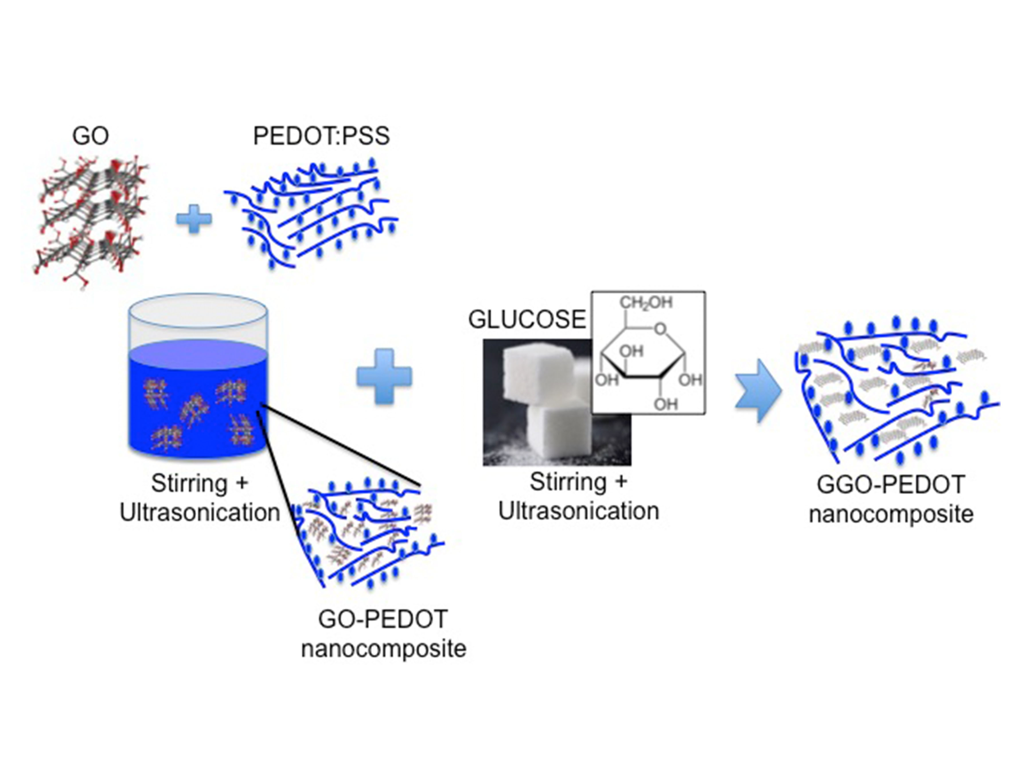

Figure 2. (a) Diffraction XRD patterns of GO, GO-PEDOT and GGO-PEDOT collected in θ-2θ scan mode drop-casted on glass. Nanocomposite precursor (b). SEM images of (c) GO-PEDOT and (d) GGO-PEDOT nanocomposite films and corresponding AFM micrograph of (e) GO-PEDOT (scan area 20×20µm², Z-range 25nm) and (f) GGO-PEDOT(scan area 50×50µm² , Z-range 25nm).

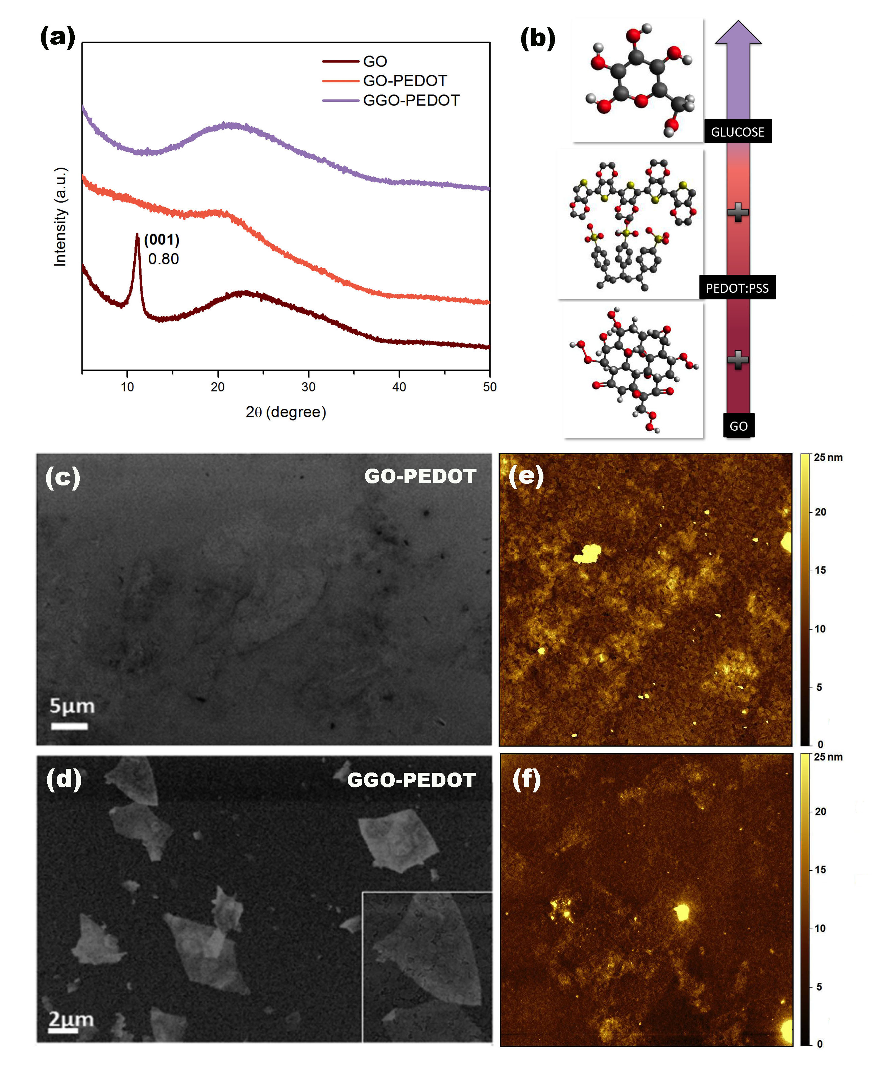

Figure 3. C/O ratio measured at different GO concentrations on (a) PEDOT:PSS and (b) G-PEDOT films. Measurements are performed (black dots) before and (red circles) after the thermal annealing of the samples.

Figure 4. (a) Contact Angle of pristine PEDOT:PSS, GO-PEDOT, G-PEDOT an GGO-PEDOT on ITO and (b) Contact Angle of Perovskite precursor drops on PEDOT:PSS, GO-PEDOT, G-PEDOT an GGO-PEDOT nanocomposite substrates. (c) SEM morphology for perovskite material deposited on the different nanocomposite substrates.

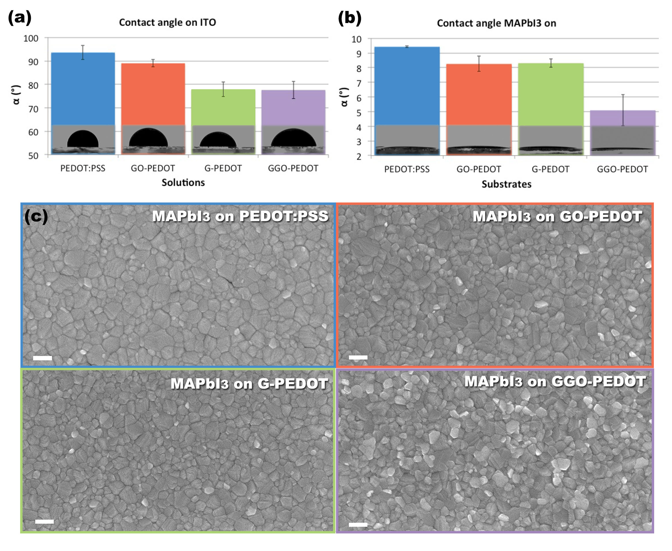

Figure 5. Current density vs. applied bias (J-V) characteristics under AM1.5 G (100 mW•cm⁻²) simulated solar illumination (color line) and in the dark (black scatter line) for PEDOT:PSS (a), GO-PEDOT (b), G-PEDOT (c) and GGO-PEDOT (d) based best devices; SEM cross section of the devices in the inset.

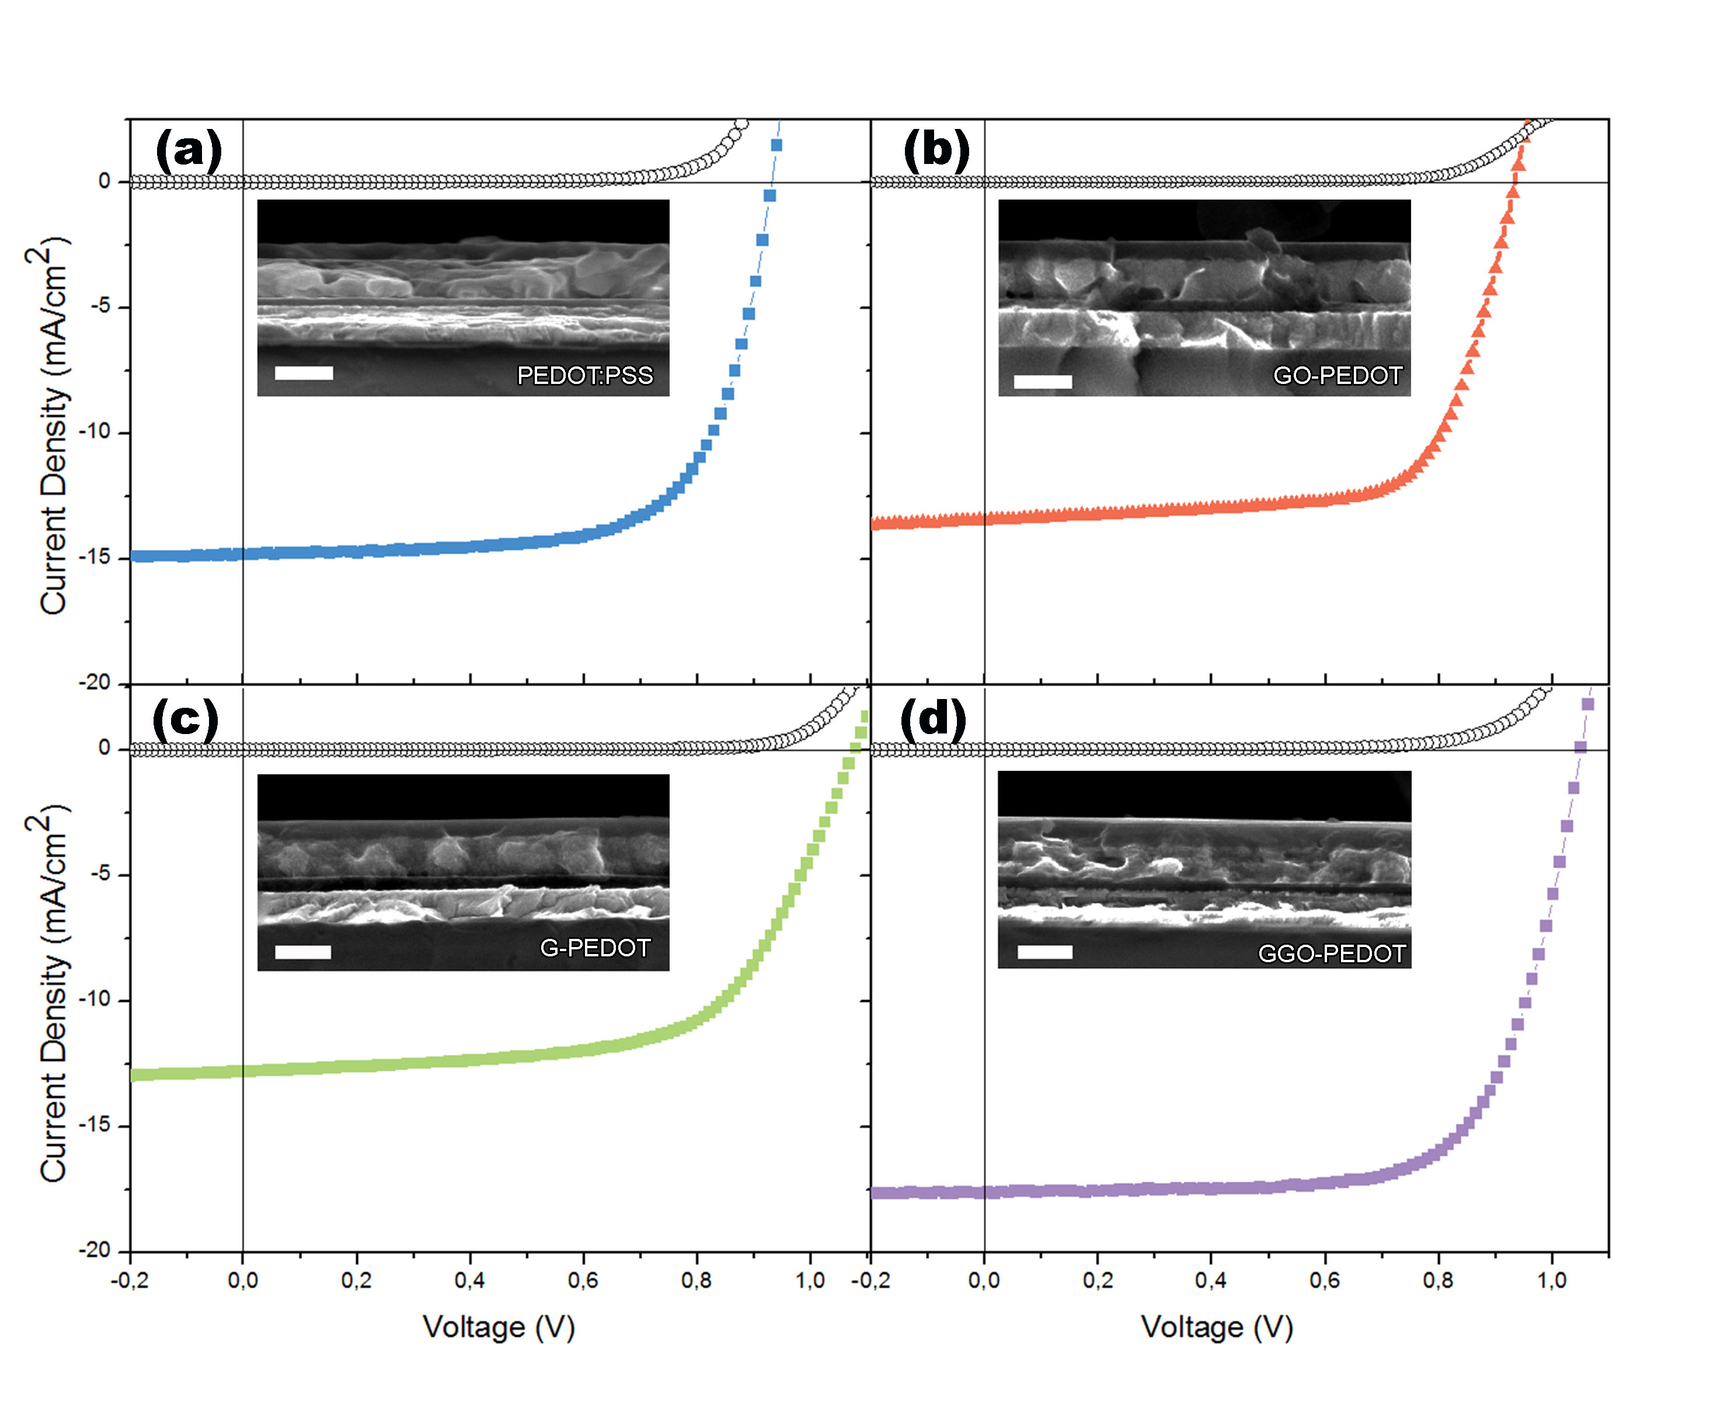

Table 1. Sheet resistances of film after annealing
 | PEDOT:PSS | GO-PEDOT | G-PEDOT | GGO-PEDOT
Sheet resistance | 50±5  [MΩ/□] | 180±20  [kΩ/□] | 10±2  [GΩ/□] | 1.9±0.2  [MΩ/□]

Table 2. Best performance and average values of the devices based on GGO-PEDOT compared with that of PEDOT:PSS, GO-PEDOT and G-PEDOT
Layer |  | Jsc (mAcm2) | Voc (V) | FF | PCE (%)
GGO-PEDOT | rev | 17.6 | 1.05 | 0.69 | 12.8
 | average | 14.3±2.3 | 1.00±0.07 | 0.66±0.06 | 9.6±1.9
PEDOT:PSS | rev | 14.9 | 0.93 | 0.68 | 9.4
 | average | 12.0±2.1 | 0.9±0.1 | 0.72±0.05 | 7.8±1.3
GO-PEDOT | rev | 13.5 | 0.93 | 0.69 | 8.7
 | average | 10.8±1.5 | 0.89±0.05 | 0.71±0.02 | 6.8±1.1
G-PEDOT | rev | 12.8 | 1.08 | 0.63 | 8.7
 | average | 12.1±2.7 | 1.01±0.07 | 0.63±0.03 | 7.5±1.0

The table of contents

The synergic effect of graphene oxide and glucose in improving the conduction properties of polymer electrolyte PEDOT:PSS and modifying the sensible interface of perovksite solar cells is reported. This method allows obtaining hysteresis-free and high V_{OC} CH₃NH₃PbI₃ devices displaying a ∼40% improvement in power conversion efficiency, evidencing minimal recombination losses and very efficient charge extraction at the electrodes.

Keywords: perovskite solar cells, graphene oxide reduction, glucose, PEDOT:PSS nanocomposite, wettability

Antonella Giuri, Sofia Masi, Silvia Colella, Alessandro Kotuvn, Simone dell’Elce, Emanuele Treossi, Andrea Liscio, Carola Esposito Corcione, Aurora Rizzo,* and Andrea Listorti

Cooperative effect of GO and Glucose on PEDOT:PSS for High VOC and Hysteresis-Free Solution Processed Perovskite Solar Cells

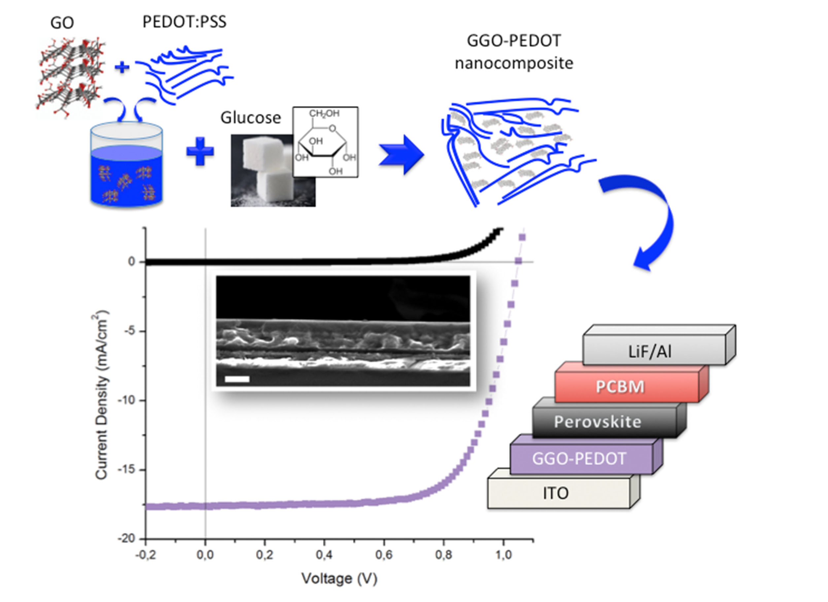

Supporting Information

Cooperative effect of GO and Glucose on PEDOT:PSS for High V_{OC} and Hysteresis-Free Solution Processed Perovskite Solar Cells

Antonella Giuri, Sofia Masi, Silvia Colella, Alessandro Kovtun, Simone dell’Elce, Emanuele Treossi, Andrea Liscio, Carola Esposito Corcione, Aurora Rizzo,* and Andrea Listorti

Figure S1. Diffraction XRD patterns of GO and GO+glucose collected in θ-2θ scan mode drop-casted on glass. The XRD spectra of glass substrate is also reported for comparison.

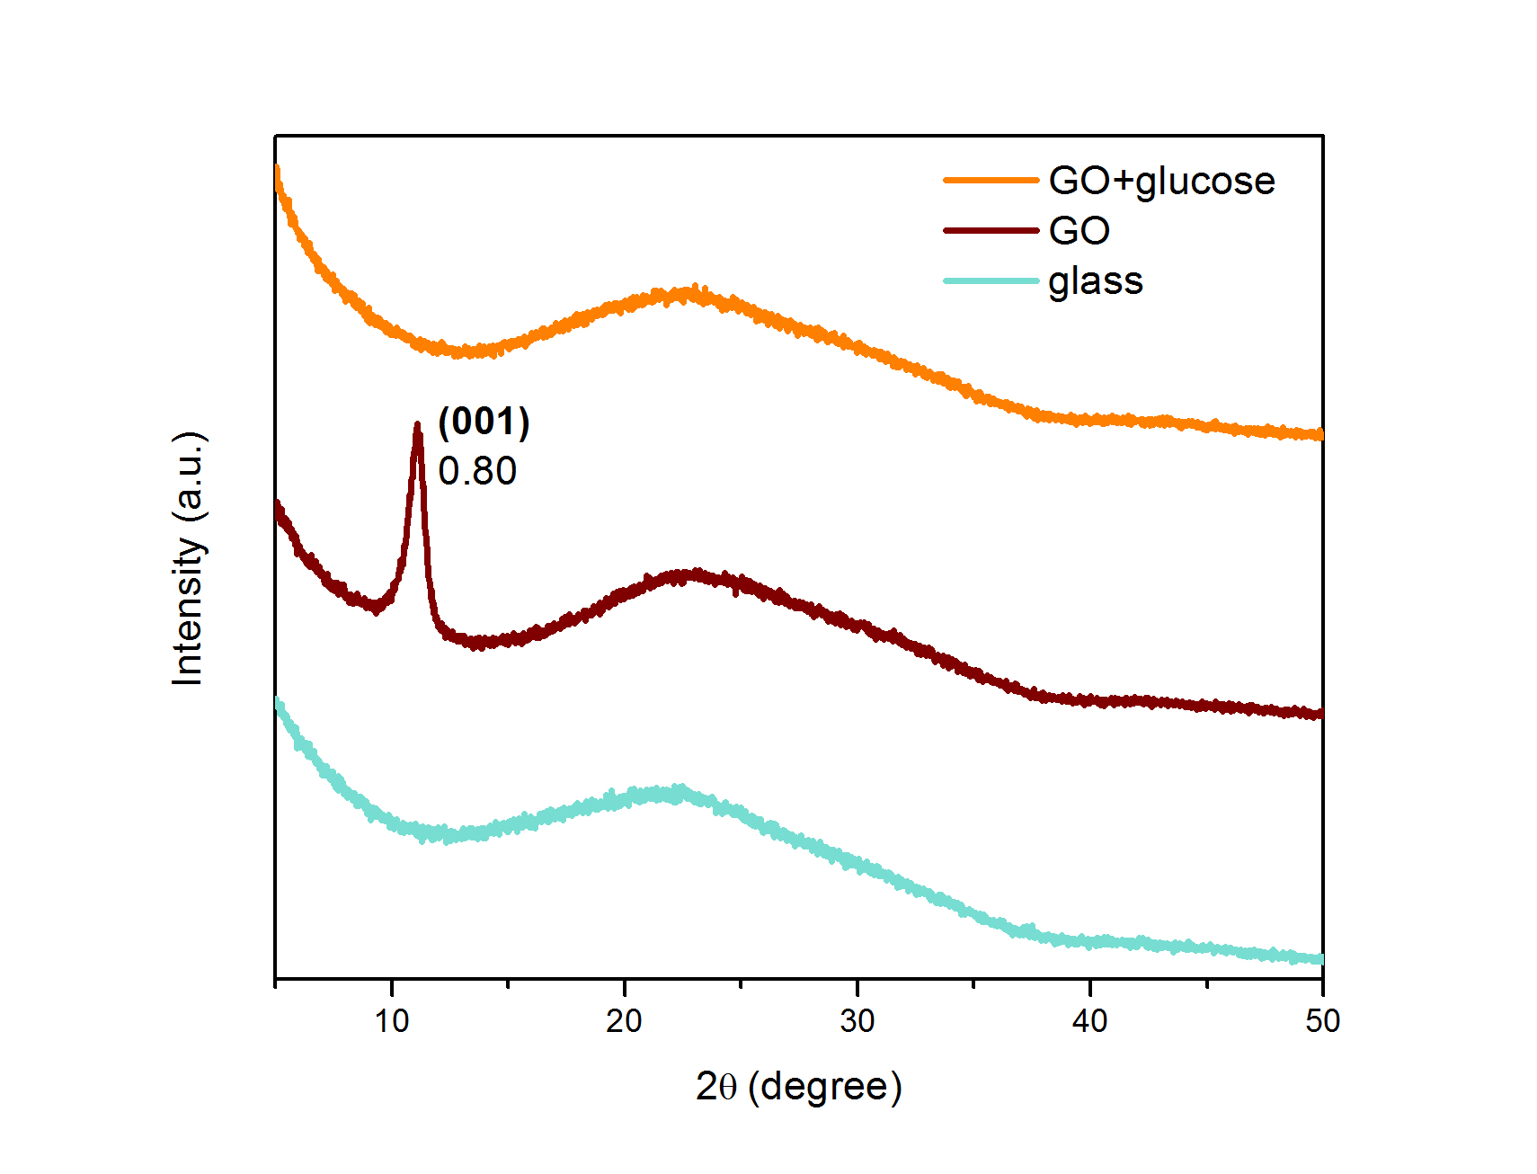

Figure S2. SEM images of GO+glucose film spin coated on ITO and annealed at 140°C for 1 h

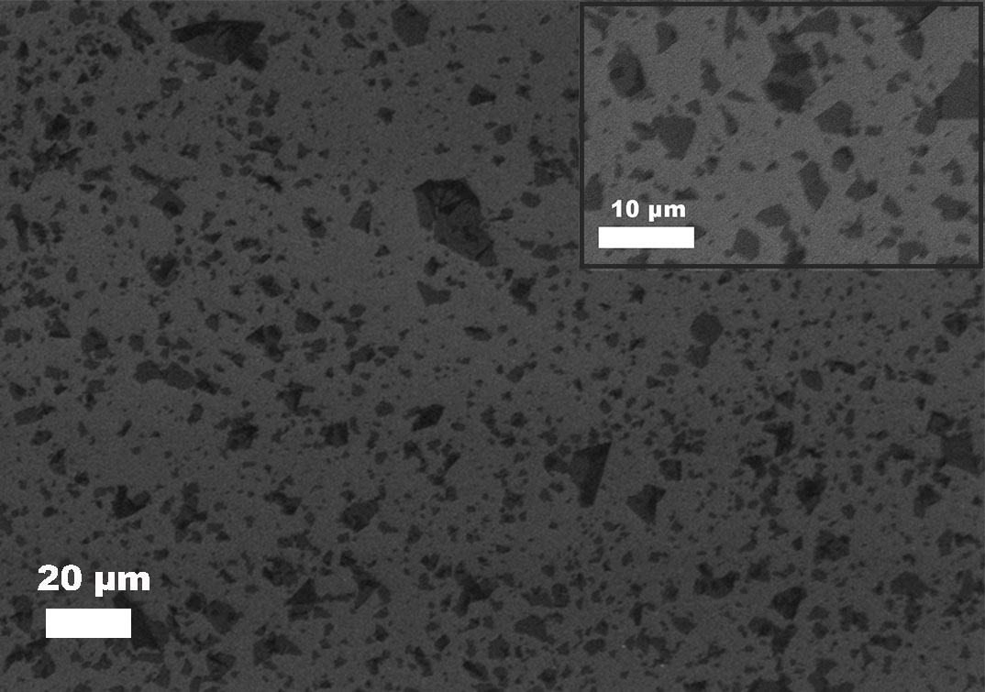

Figure S3. SEM images of PEDOT:PSS and G-PEDOT films spin coated on ITO and annealed at 140°C for 1 h

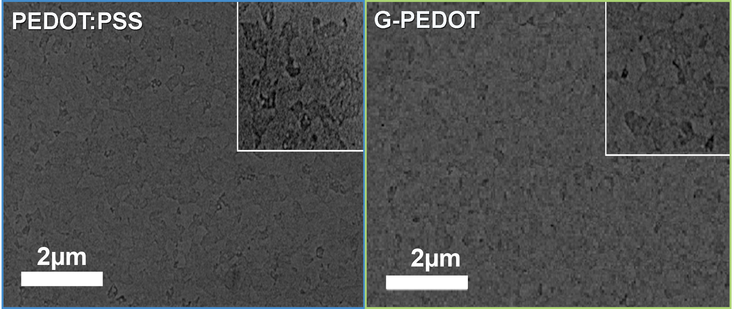

Figure S4. UV-vis absorption spectra of (a) GO; (b) glucose and (c) GO+glucose, drop-casted onto quartz glass substrates, and (d) GGO-PEDOT spin-coated quartz glass substrates, before and after thermal annealing at 140°C.
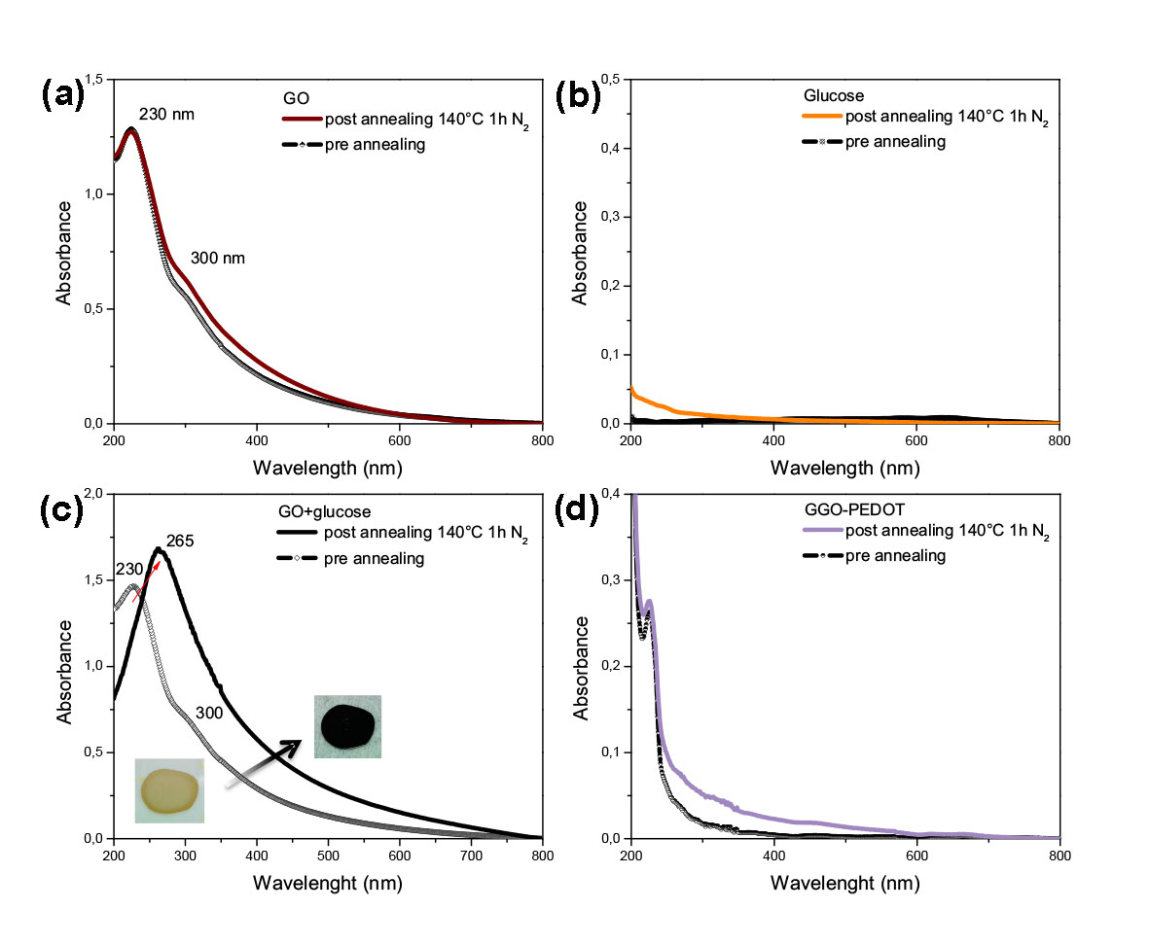

Figure S5. UV-vis absorption spectra of GGO-PEDOT compared with PEDOT:PSS, GO-PEDOT, and G-PEDOT, spin-coated onto quartz glass substrates, after thermal annealing

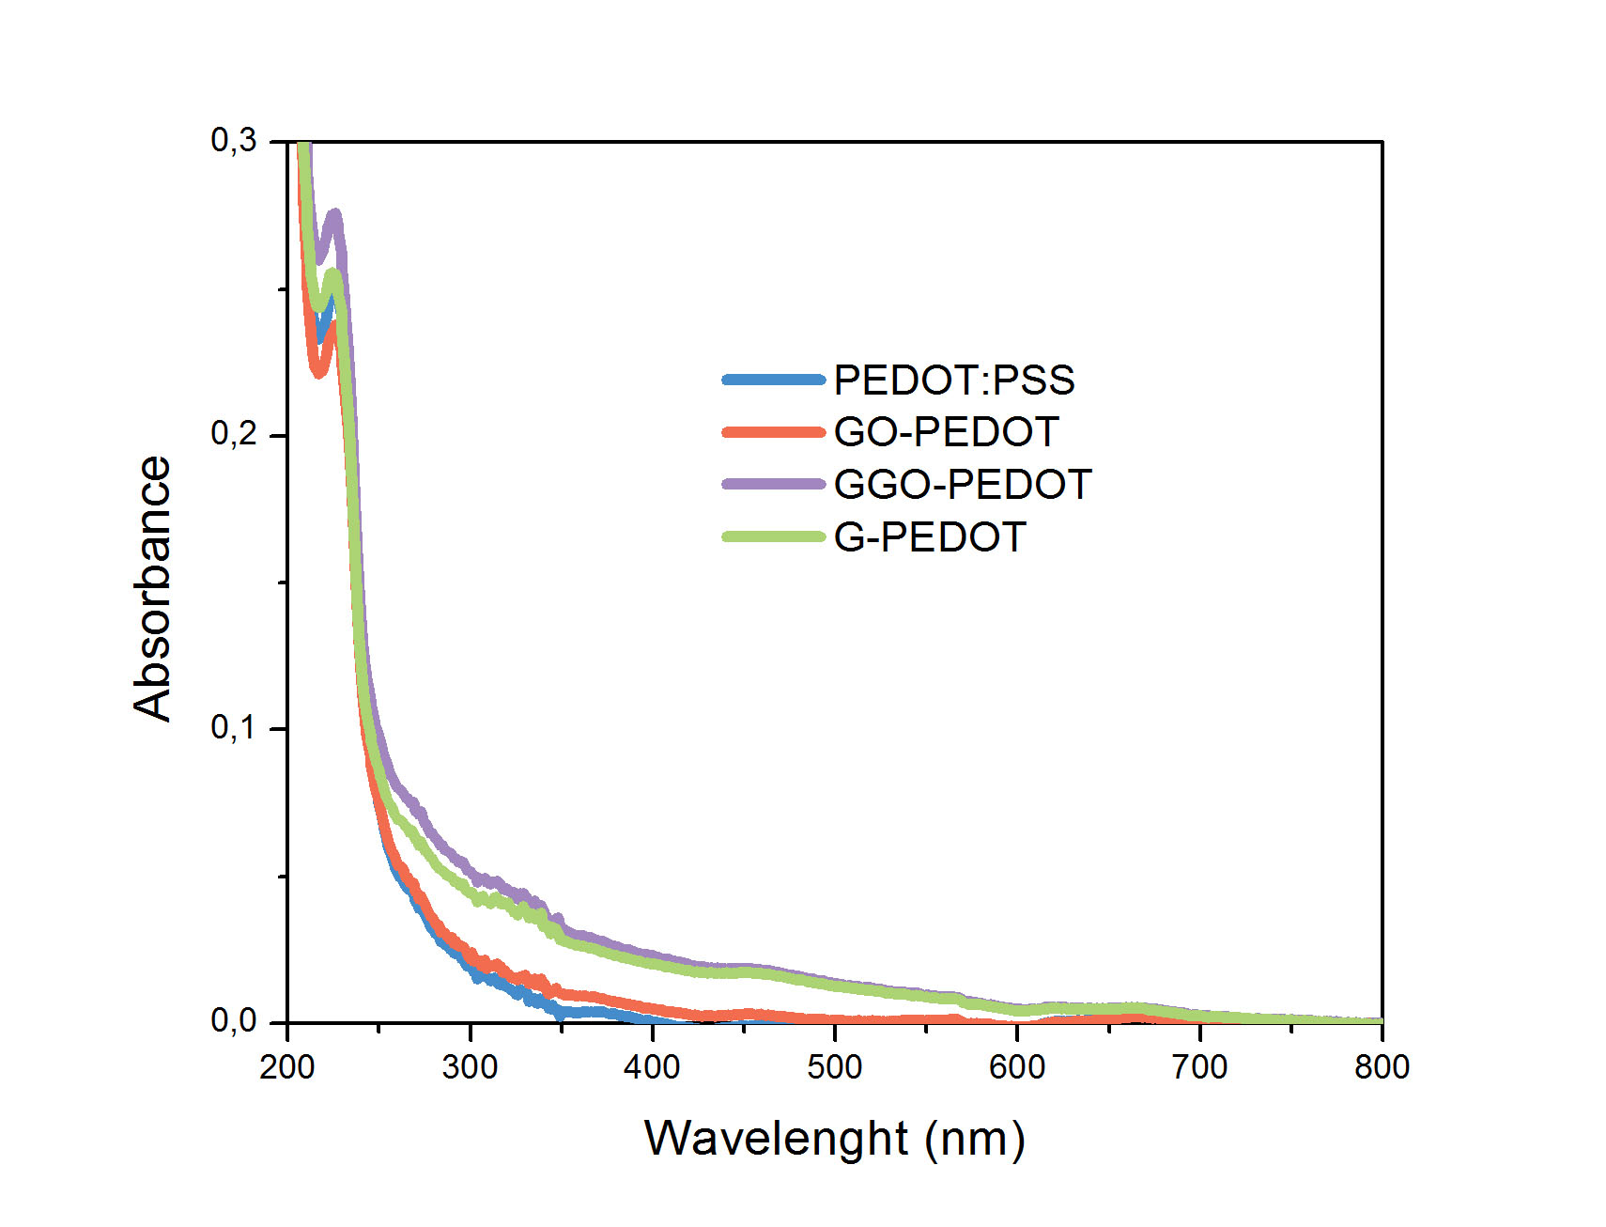

Figure S6 - XPS measurements performed on three samples: a) pristine PEDOT:PSS film, b) GO-PEDOT and c) GGO-PEDOT. All the samples were measured after annealing (red triangle) and as deposited (black circle) annealing at 140°.

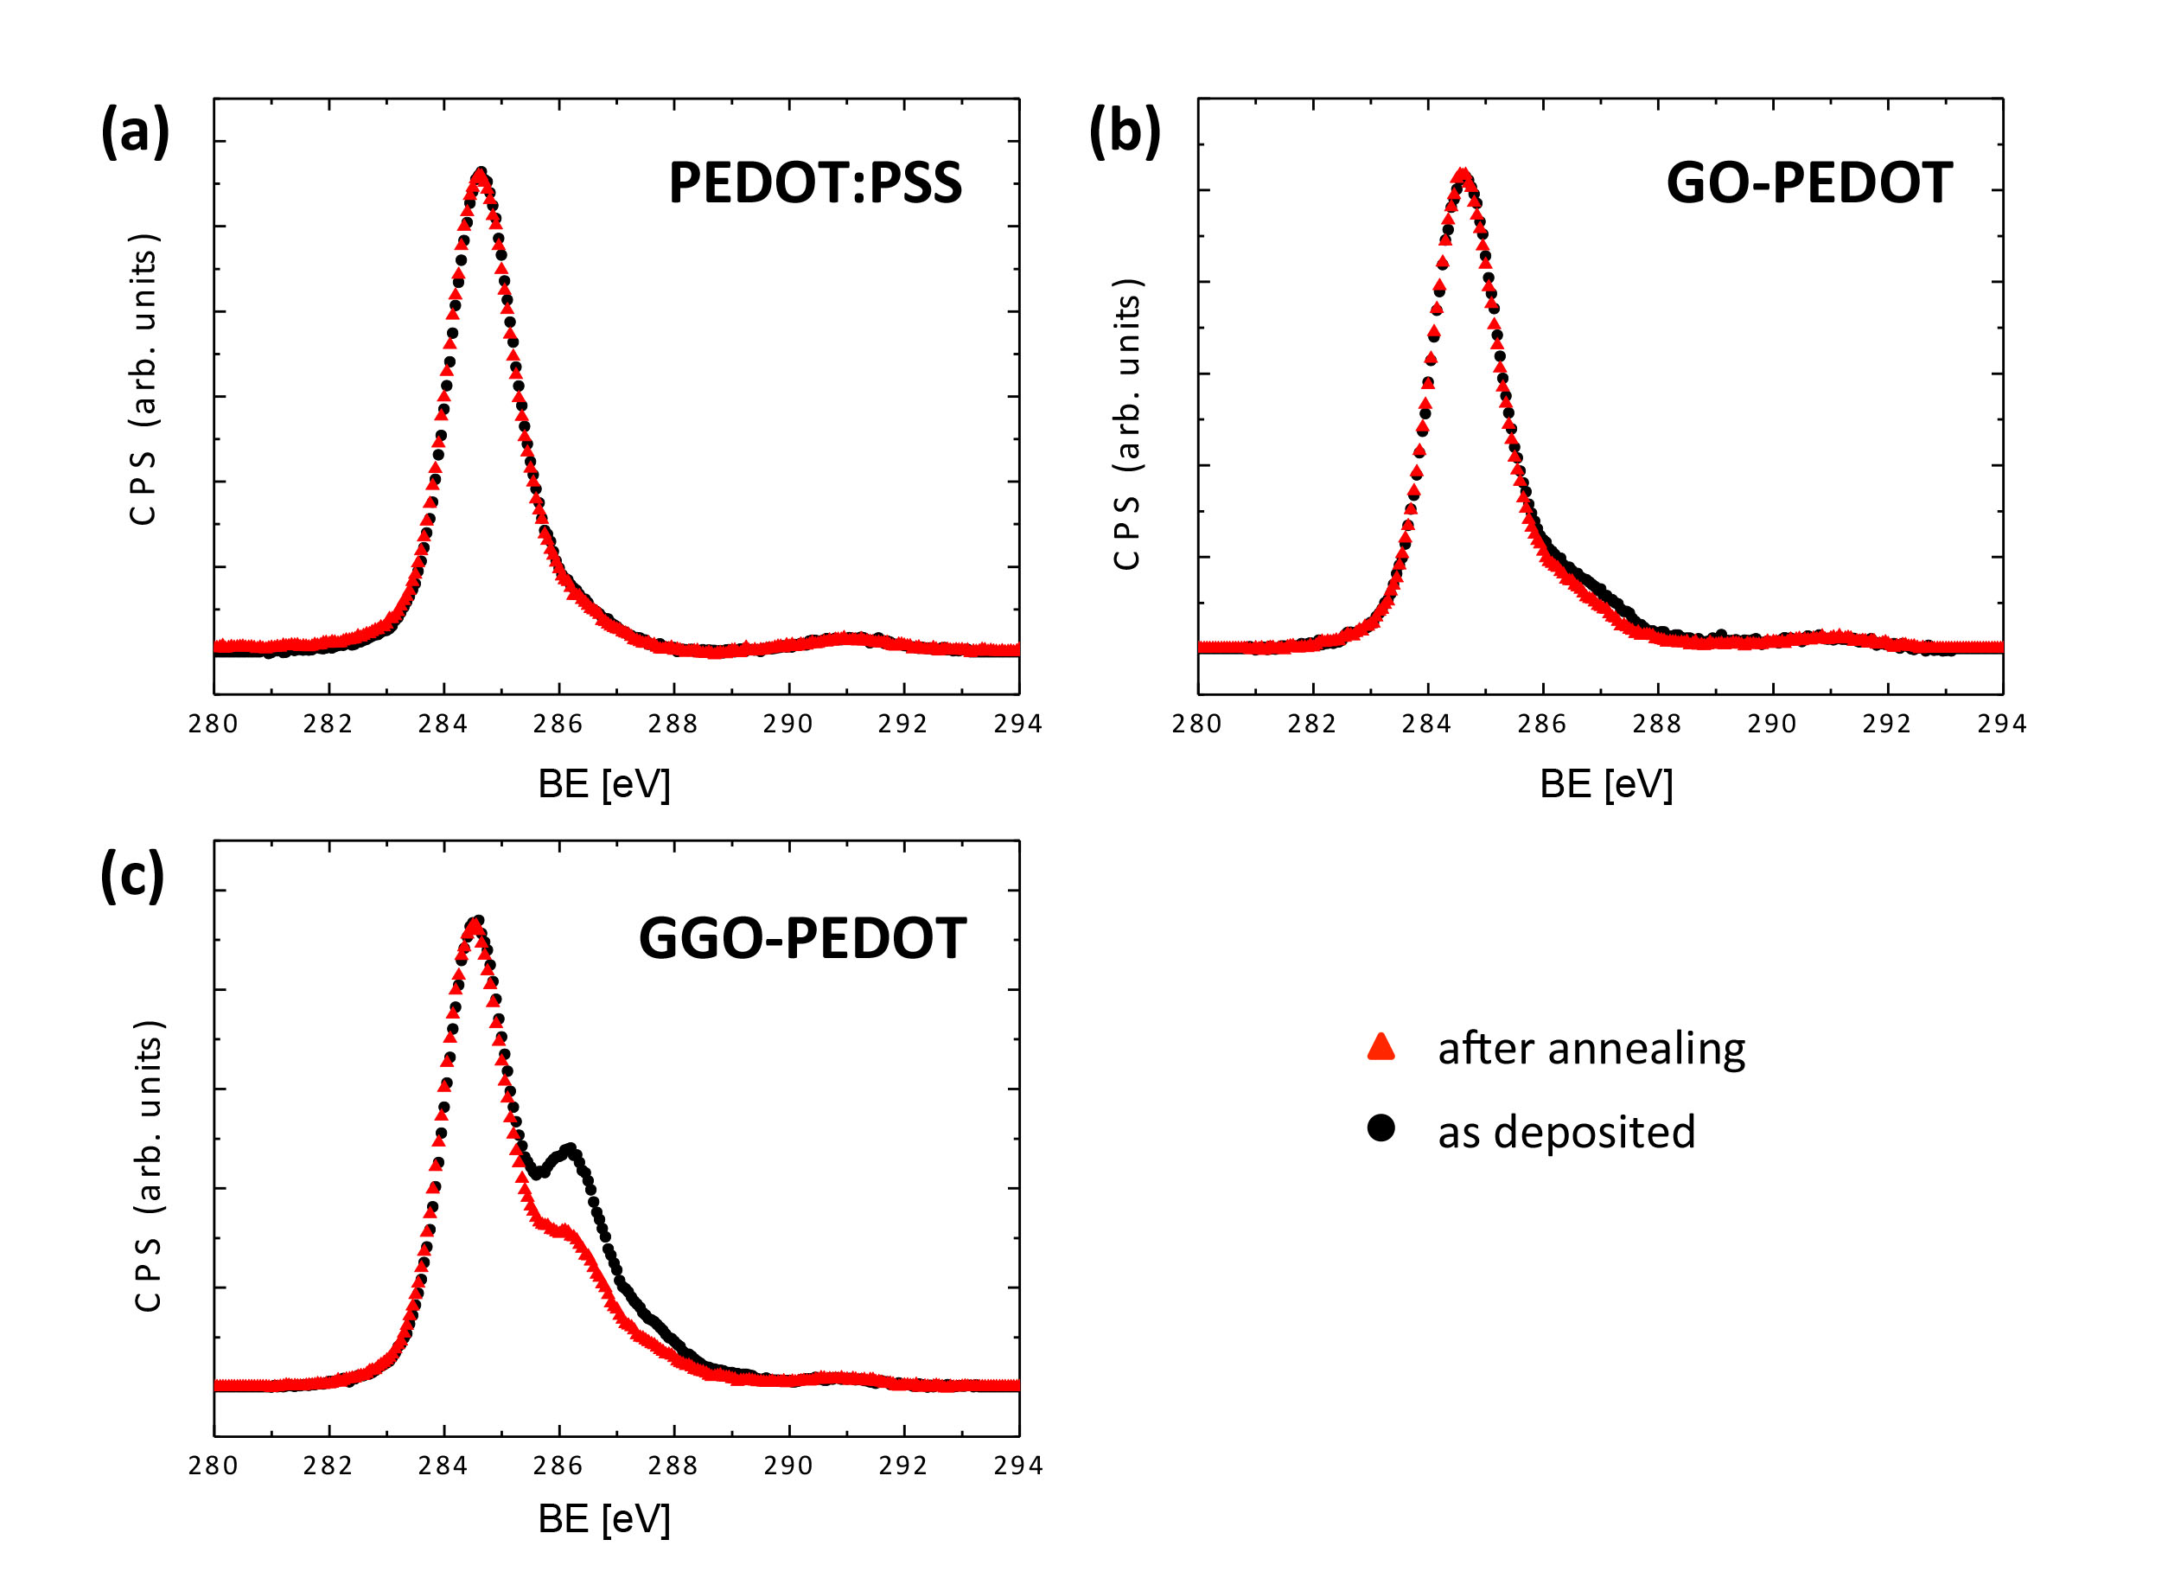

XPS analysis of the surveys of C 1s show a remarkable changing due to the annealing only in the case of GO-PEDOT and glucose.
XPS spectra of pure PEDOT:PSS deposited on ITO confirms the presence of the expected elements ^{[1]}: Carbon (C 1s), Oxygen (O1s), Sulfur (S 2p, S 2s) and Sodium (Na 1s).
XPS measurements are performed on six samples: 1) pristine PEDOT:PSS film, 2) GO-PEDOT, 3) GGO-PEDOT; then the three spectra was repeated after annealing at 140°. Figure S6 XPS shows the evolution of C 1s spectra for the six different samples. It is possible to observe that the component at 286.2 eV (C-O-C/C-OH) have a small increase by adding GO to PEDOT:PSS (figure S6(b)), while the increase becomes significant by adding Glucose (figure S6(b)). The effect of annealing is visible in both composites GO-PEDOT and GGO-PEDOT, figure S6 (b) and (c). The evidence of the annealing is an important confirmation of the presence of the GO: the spectra with only PEDOT:PSS has negligible change after annealing (figure S6 (a)), while by adding GO it is possible to observe (figure S6 (b)) that the epoxy/alcoholic component decrease. In order to confirm the presence of GO several concentration of GO was used (0, 0.05, 0.10, 0.15, 0.20, 0.25) as reported in figure 3. Particular attention was set on C 1s and the C/O ratio in order to monitor the presence of GO and Glucose in the film. Shirley background was subtracted to the spectra and Voigt line shape was used for fitting five different synthetic components: C=C bond (284,4 eV), C-C (285,0 eV), C-O-C/C-OH (286,2 eV), O-C-O (287,7 eV) and π-> π* transition (291 eV). In the C1s signal of PEDOT is expected the presence of the C-C and C=C bonds, while PSS presents C-C, C=O, C-S and C-O-C bonds.
GO presents C=C, C-C, C-O-C, C=O, O-C=O functional groups ^{[2]}, Glucose presents quite similar functional groups ^{[3]}: C-C, C-O, O-C-O. The chemistry of the GGO-PEDOT:PSS is complex, therefore it was chosen to use the simpler fitting model previously reported in order to monitor the oxidation degree of the composite. The FWHM of all synthetic components were below 1,6 eV.
C/O ratio was calculated by few chemical consideration about the area of signal associated to the chemical groups of C 1s: i) in epoxy group (C-O-C) Oxygen is bond to 2 carbon atoms (A_{C-O-C} is the % area of C-O-C group), ii) in the O=C-O group there are two Oxygens for each Carbon atom (A_{O=C-O} is the % area of O=C-O group). So it is possible to write the C/O ratio as:
$C/O=\frac{A_{sp2}+A_{sp3}+A_{C-O-C}+A_{O=C-O}}{A_{C-O-C}/2+2∙A_{O=C-O}}$ .

Table S1. C/O data relative to Figure 3 (a)

GO concentration GO-PEDOT | Before Annealing | After Annealing
0 | 27 ± 3 | 29 ± 3
0.05 | 24 ± 3 | 25 ± 3
0.10 | 17.9 ± 3 | 17.6 ± 3
0.15 | 24 ± 3 | 28 ± 3
0.20 | 9.4 ± 2 | 12.4 ± 2
0.25 | 13 ± 2 | 21 ± 2

Table S2. C/O data relative to Figure 3 (b)
GO concentration GGO-PEDOT | Before Annealing | After Annealing
0 | 3.5 ± 0.7 | 4.7 ± 0.8
0.05 | 3.6 ± 0.7 | 4.7 ± 0.8
0.10 | 4.0 ± 0.7 | 6.4 ± 0.9
0.15 | 3.6 ± 0.7 | 6.8 ± 0.9
0.20 | 3.5 ± 0.7 | 6.5 ± 0.7
0.25 | 3.8 ± 0.8 | 6.2 ± 0.9

Table S3 Thermal analyses of PEDOT:PSS and doped PEDOT:PSS films

Samples | 1° step |  | 2° step
 | H2O loss  % | Dehyidration energy (kJ/mol) | Onset point  °C
PEDOT:PSS | 22,7 | 39,3 | 268
GO-PEDOT | 18,7 | 33,4 | 272
GGO-PEDOT | 26,8 | 12,6 | 265
G-PEDOT | 28,4 | 22,0 | 258

Figure S7 TGA curves of the PEDOT:PSS, GO-PEDOT, GGO-PEDOT, G-PEDOT films.
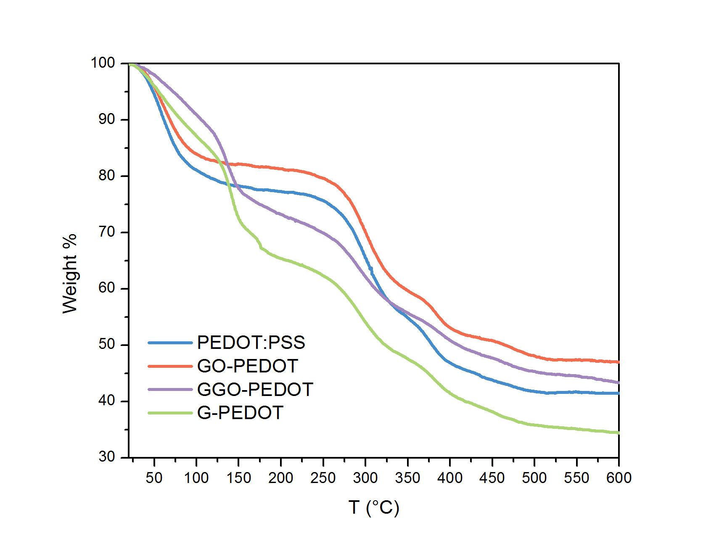

Figure S8. AFM morphology for perovskite material deposited on the different substrates, scan are is 3×3µm².
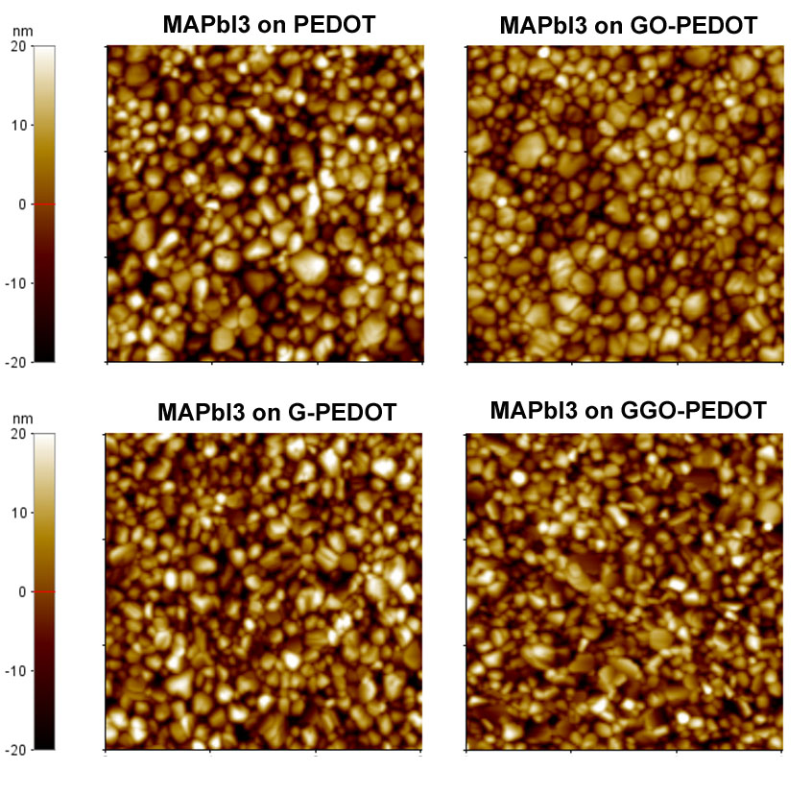

Figure S9. Diffraction XRD patterns of MAPbI₃ on PEDOT:PSS, GO-PEDOT, G-PEDOT and GGO-PEDOT substrates collected in θ-2θ scan mode. Symbols: * indicates (002)/(110), (004)/(220), (310), (224), (006)/(330) reflections that are characteristic of the MAPbI₃ material, ° identifies ITO substrate reflections.

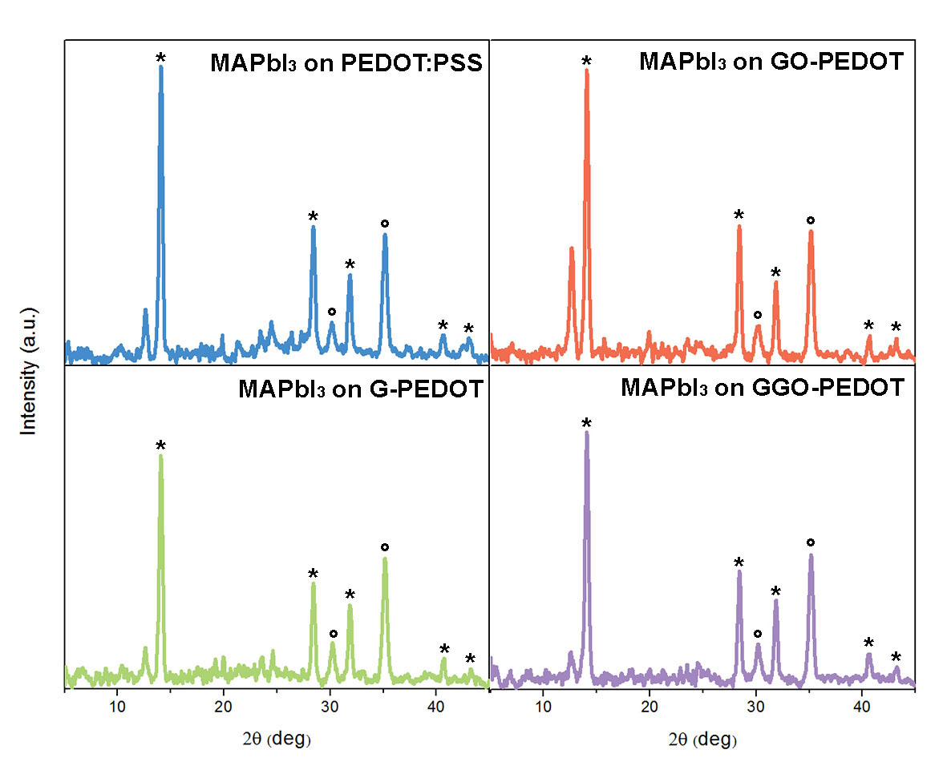

Figure S10. Statistics on the FF, V_{OC}, J_{SC}, PCE for all the devices tested.

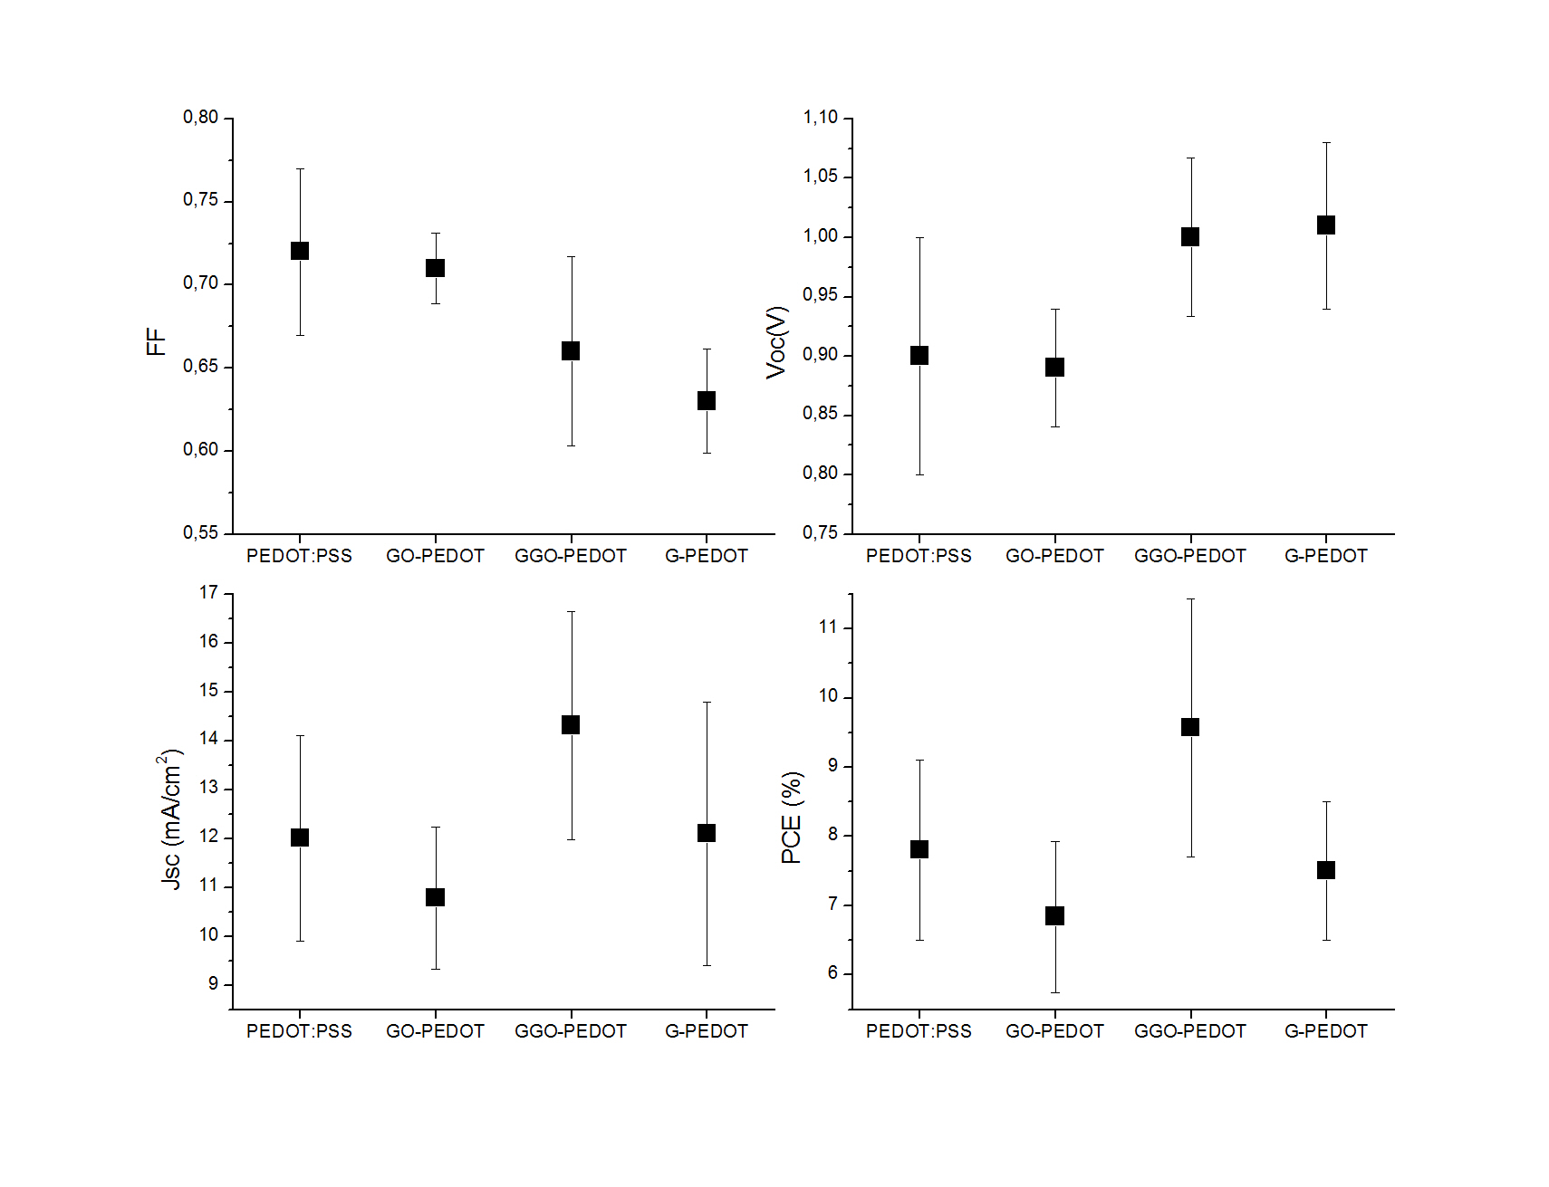

Figure S11. IPCE curves for PEDOT:PSS, GO-PEDOT, G-PEDOT and GGO-PEDOT based solar cells.

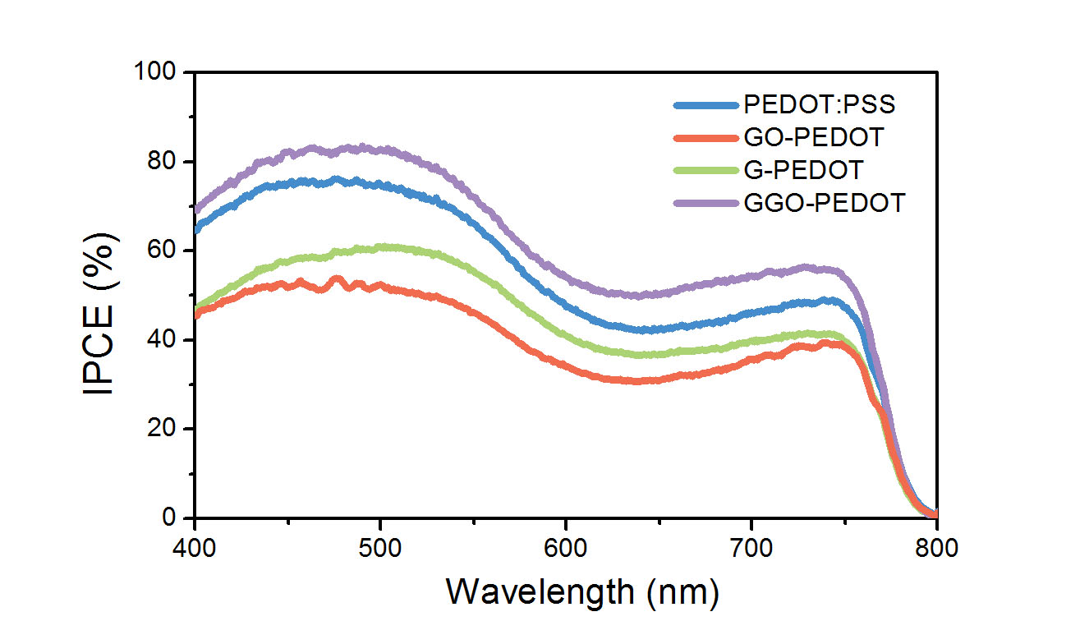

Figure S12. J-V characteristic of the best device based on the GGO-PEDOT nanocomposite compared with that on G-PEDOT film.

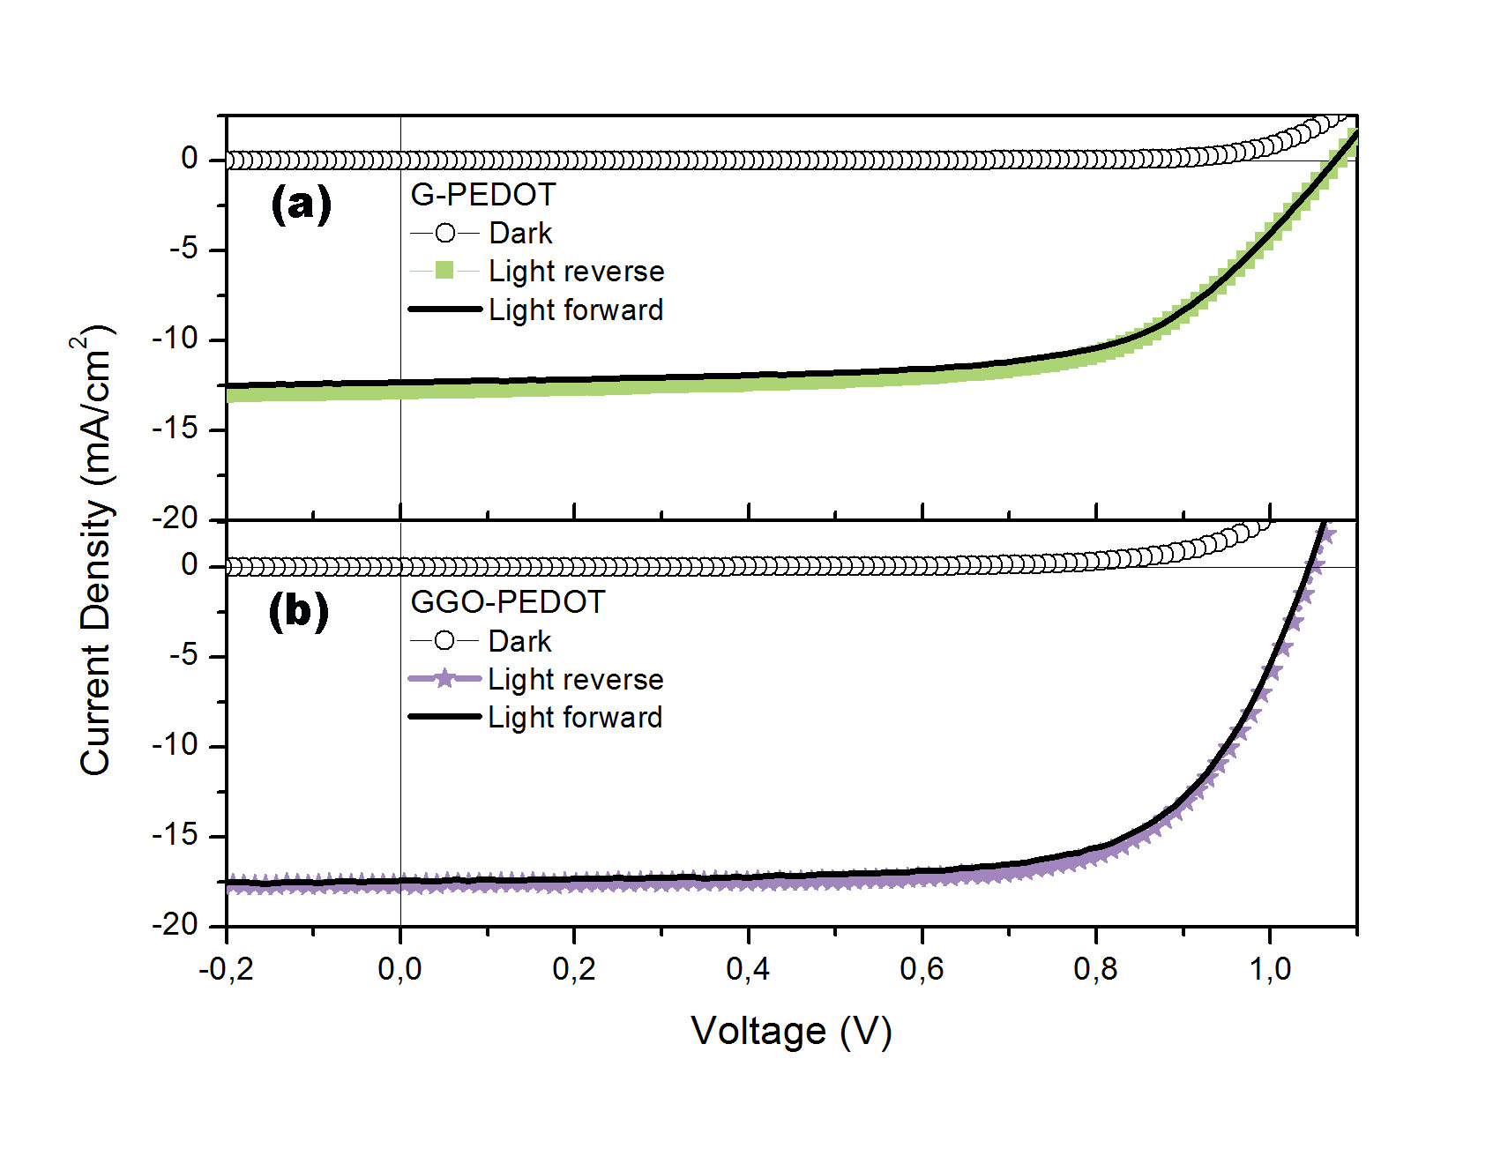

[1] Greczynski, G; Kugler, T. H.; Keil, M.; Osikowicz, W.; Fahlman, M.; Salaneck W. R.,
J. Electron. Spectrosc. Relat. Phenom. 2001, 121, 1-17.
[2] Russier, J.; Treossi, E.; Scarsi, A.; Perrozzi, F.; Dumortier, H.; Ottaviano, L.; Meneghetti, M.; Palermo, V.; Bianco, A., Nanoscale 2013, 5 (22), 11234-11247.
[3] Stevens, J. S.; Schroeder, S. L. M., Surface and Interface Analysis 2009, 41 (6), 453-462.

